<https://www.youtube.com/watch?v=sDv4f4s2SB8&list=PLblh5JKOoLUICTaGLRoHQDuF_7q2GfuJF&index=47>



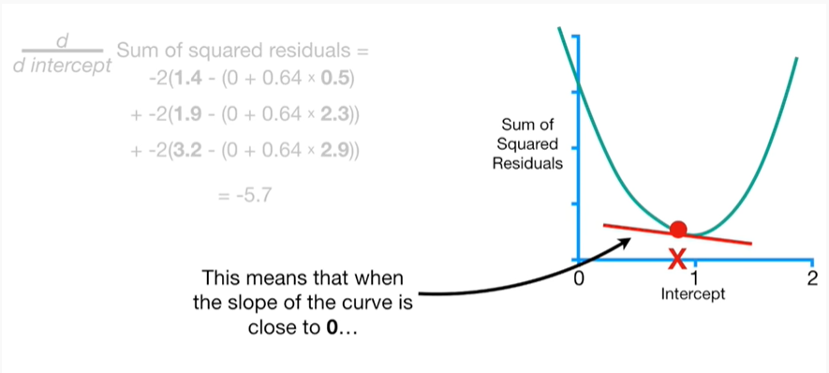

This means that when the slope of the curve is close to zero

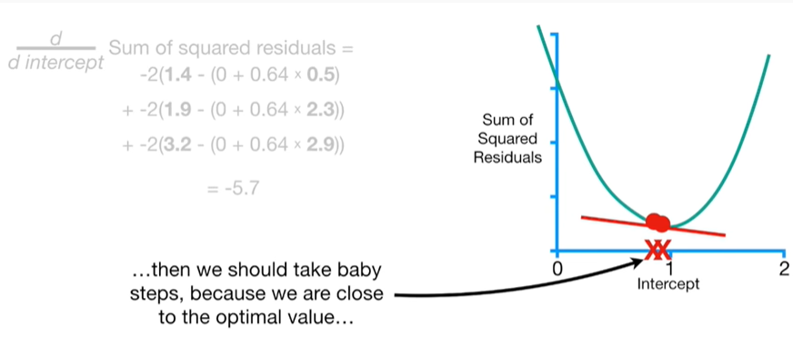

then we should take baby steps, because we are close to the optimal value

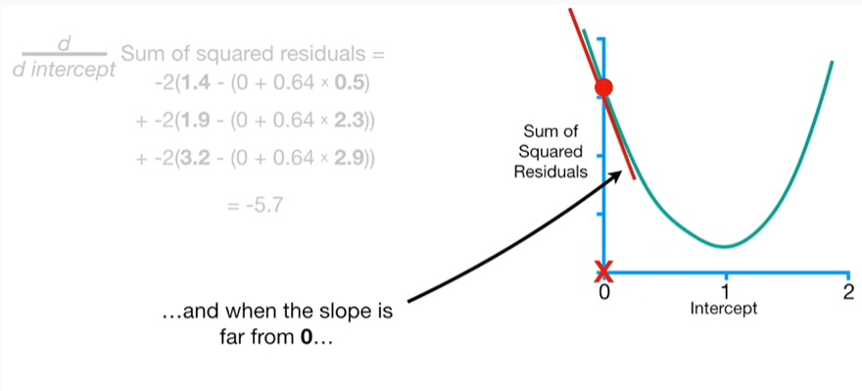

and when the slope is far from zero

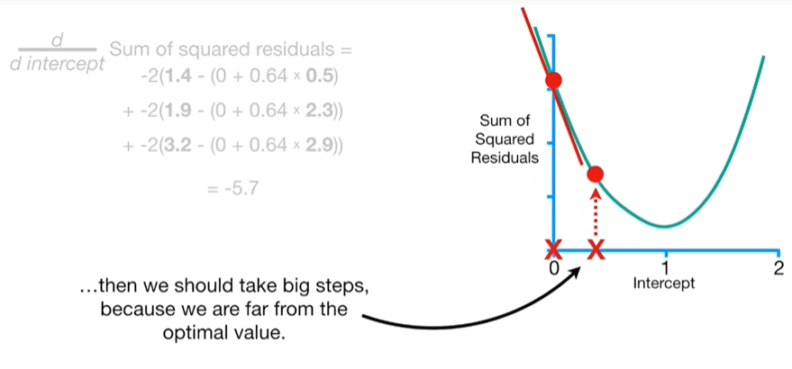

then we should take big steps because we are far from the optimal value.

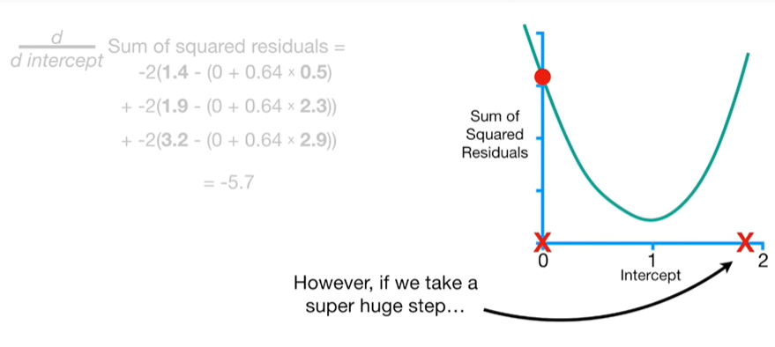

However, if we take a super huge step

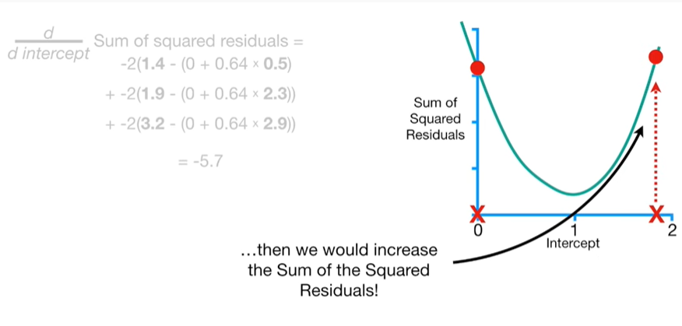

then we would increase the sum of the squared residuals !

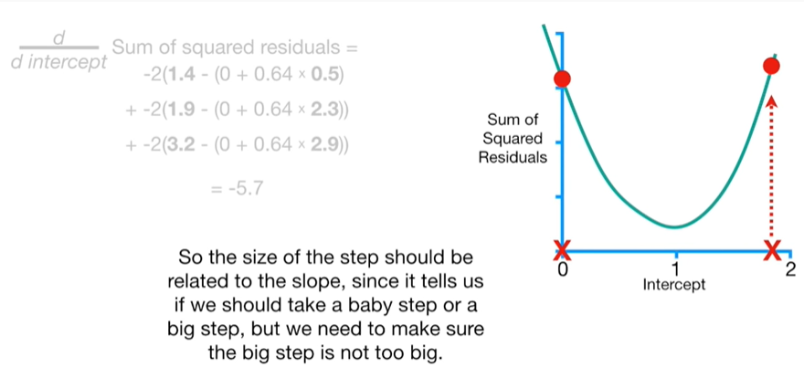

So the size of the step should be related to the slope since it tells us if we should take a baby step or a big step but we need to make sure the big step is not too big.

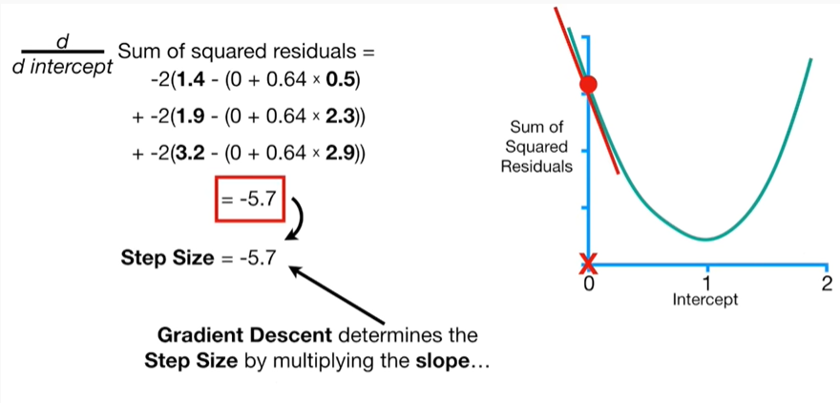

Gradient descent determines the step size by multiplying the slope

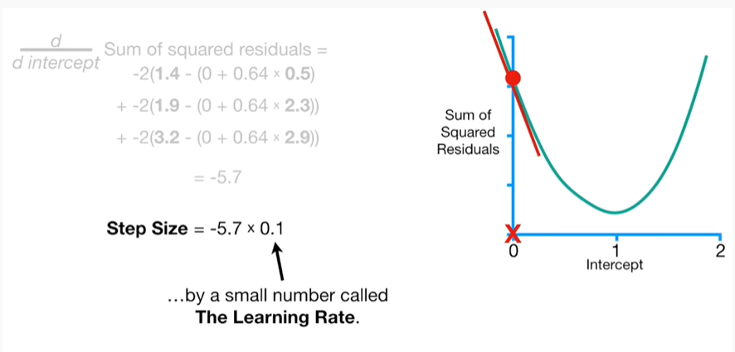

by a small number called the learning rate.

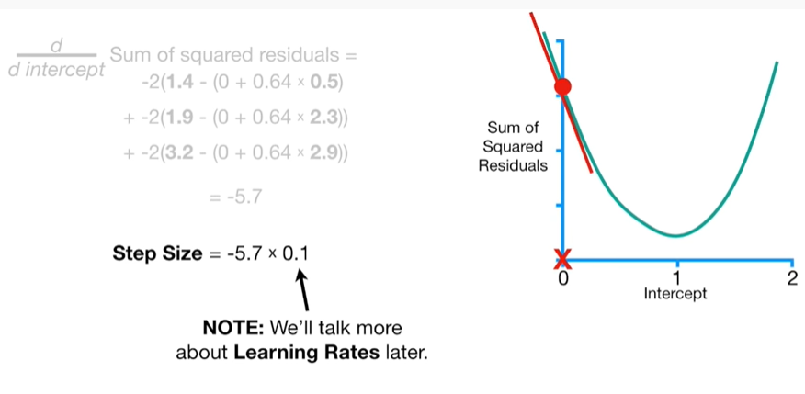

Note : we'll talk more about learning rates later.

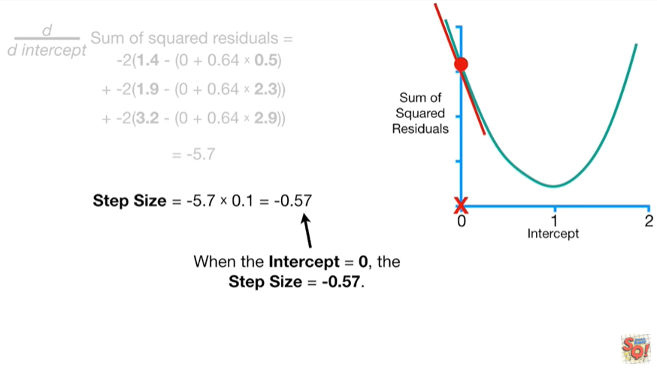

When the intercept equals zero the step size equals negative five point seven.

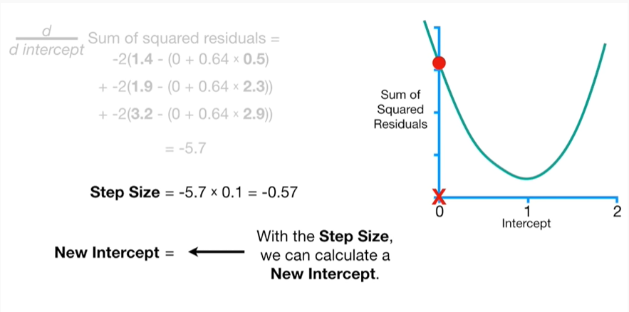

With the step size, we can calculate a new intercept.

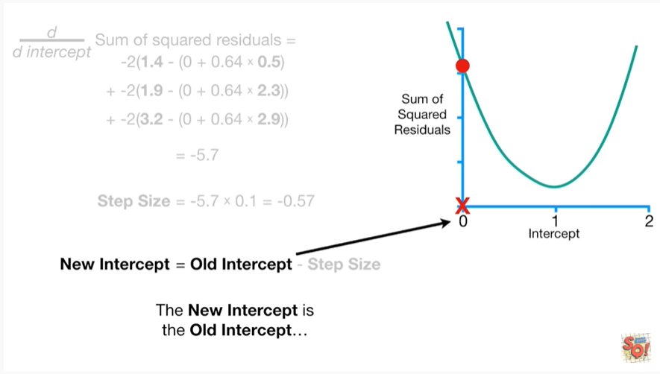

The new intercept is the old intercept

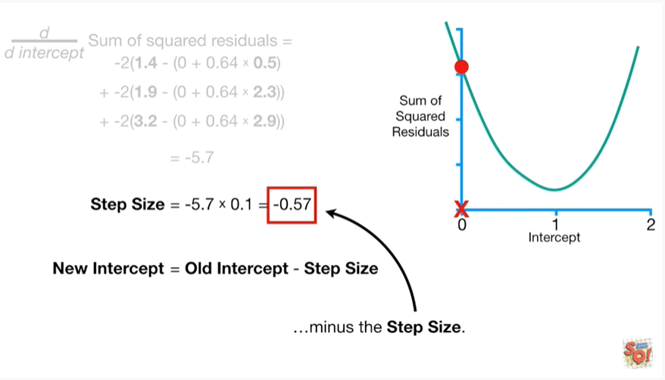

minus the step size.

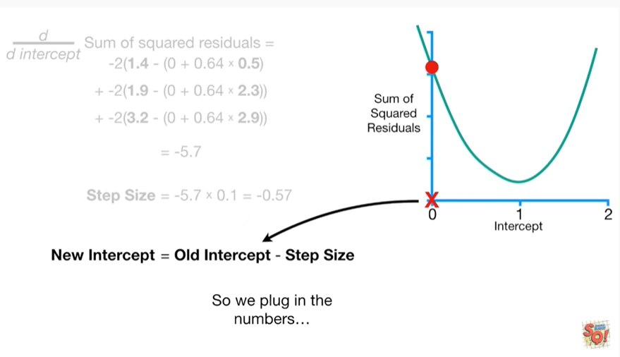

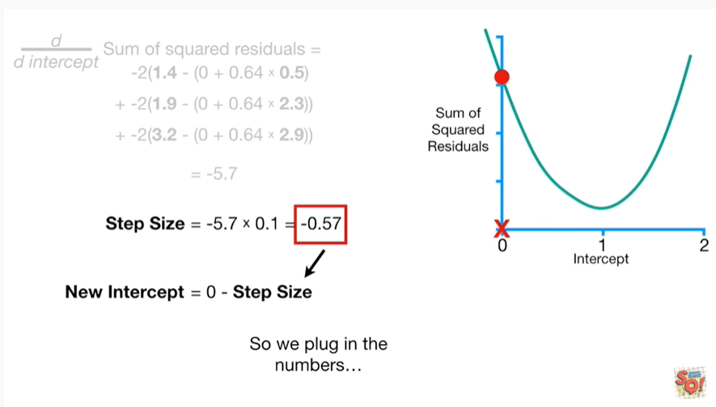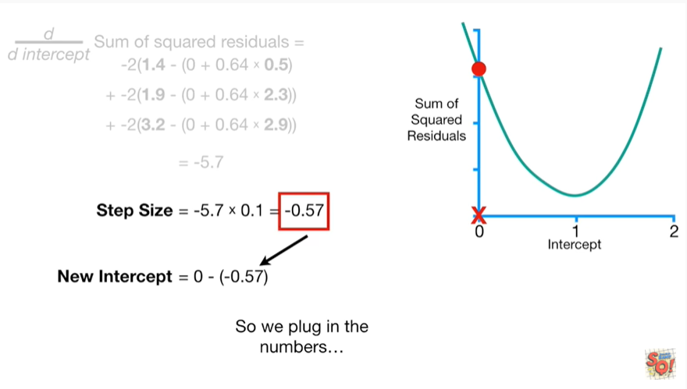

So we plug in the numbers

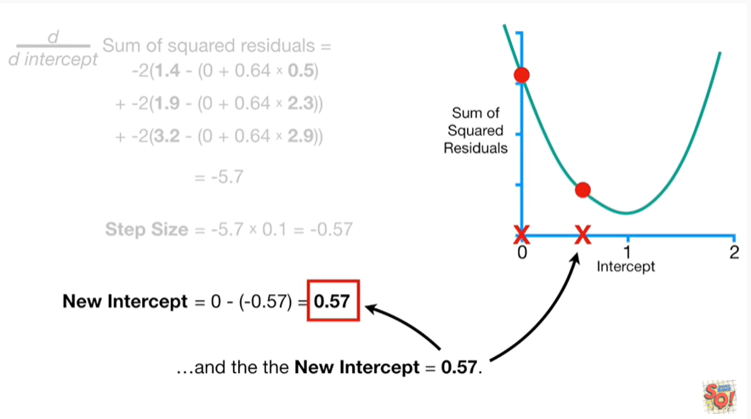

and the new intercept equals zero point five seven.

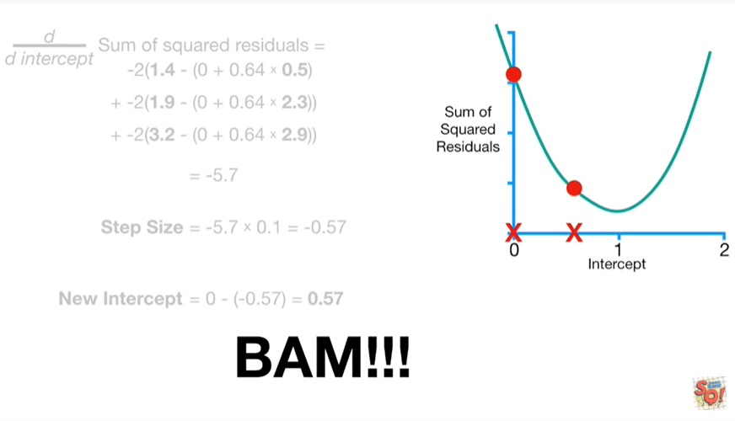

BAM !!!

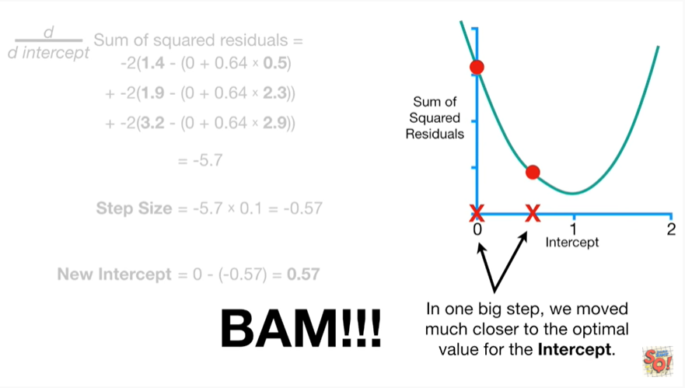

In one big step, we moved much closer to the optimal value for the intercept.

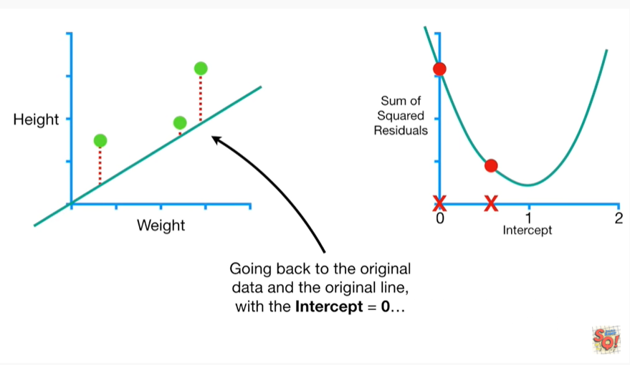

Going back to the original data and the original line with the intercept equals zero

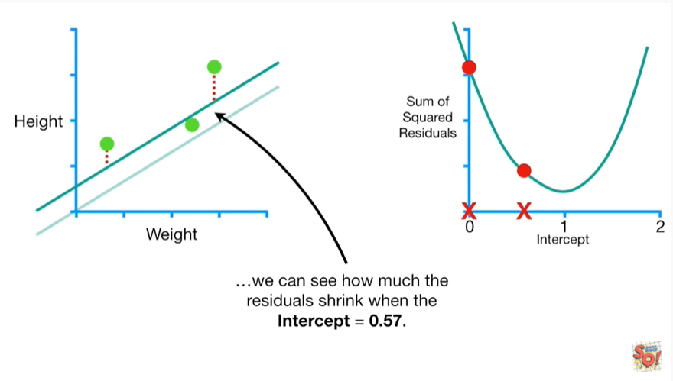

we can see how much the residual shrink when the intercept equals zero point five seven.

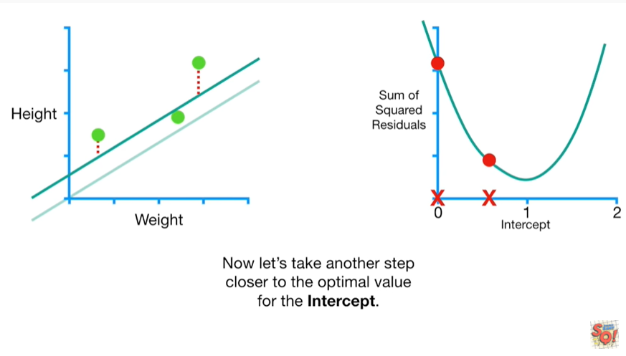

Now let's take another step closer to the optimal value for the intercept.

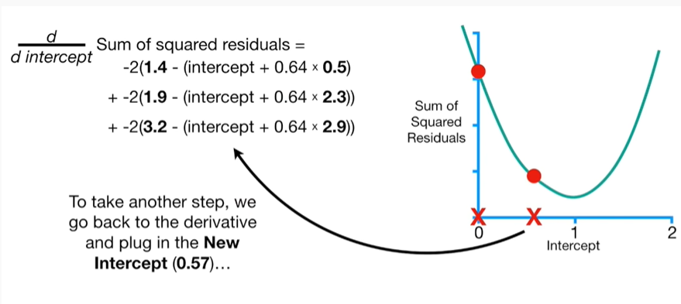

To take another step we go back to the derivative and plug in the new intercept

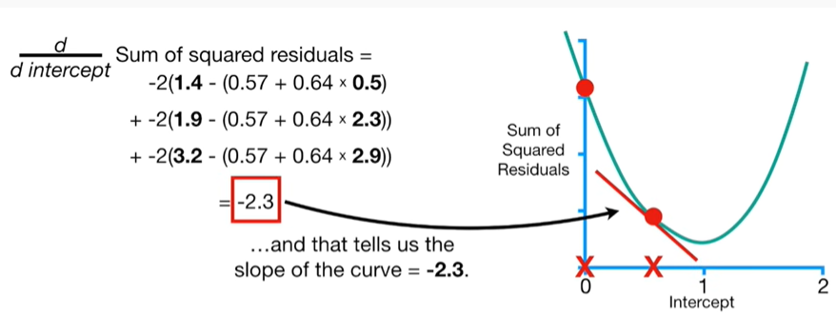

and that tells us the slope of the curve equals negative two point three.

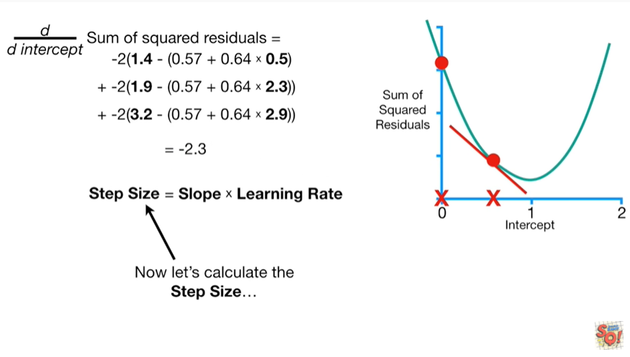

Now let's calculate the step size

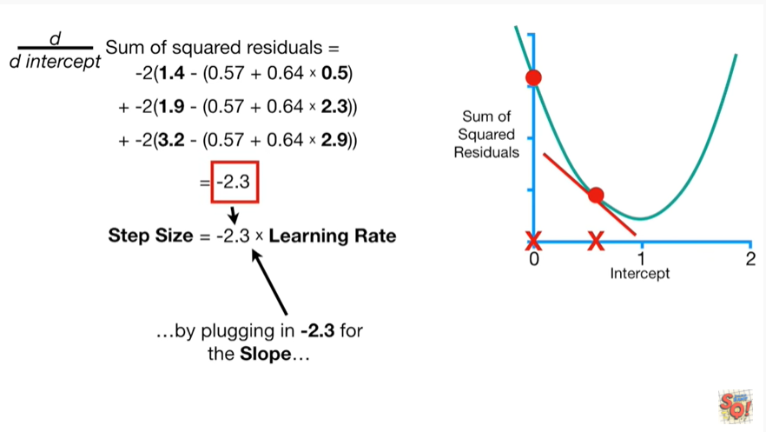

by plugging in negative two point three for the slope

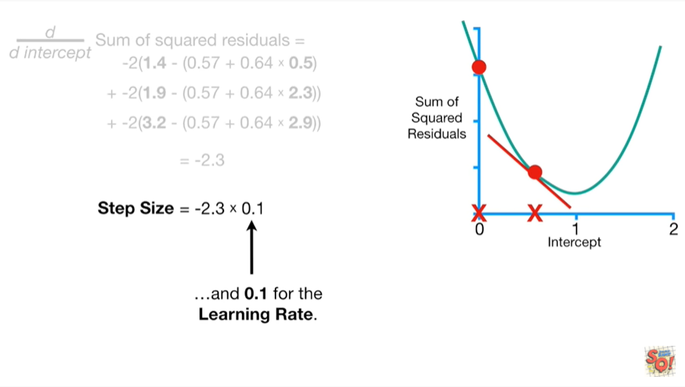

and zero point one for the learning rate.

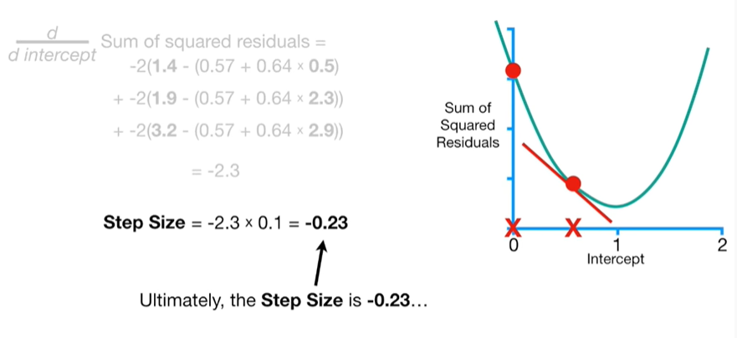

Ultimately, the step size is negative two point three

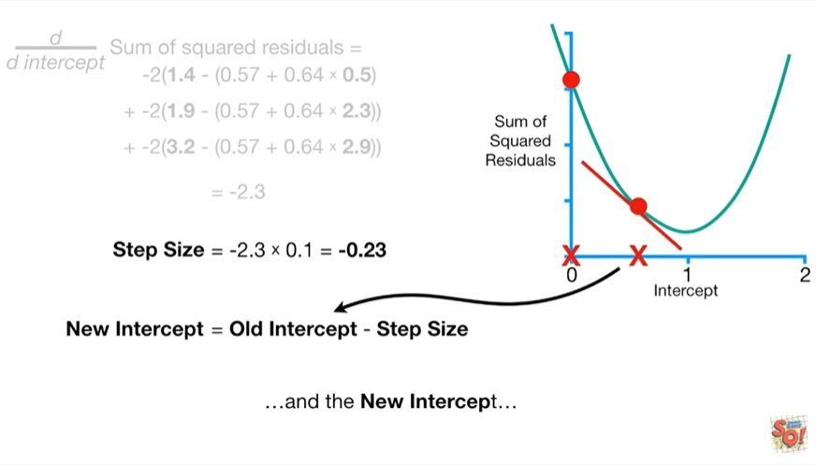

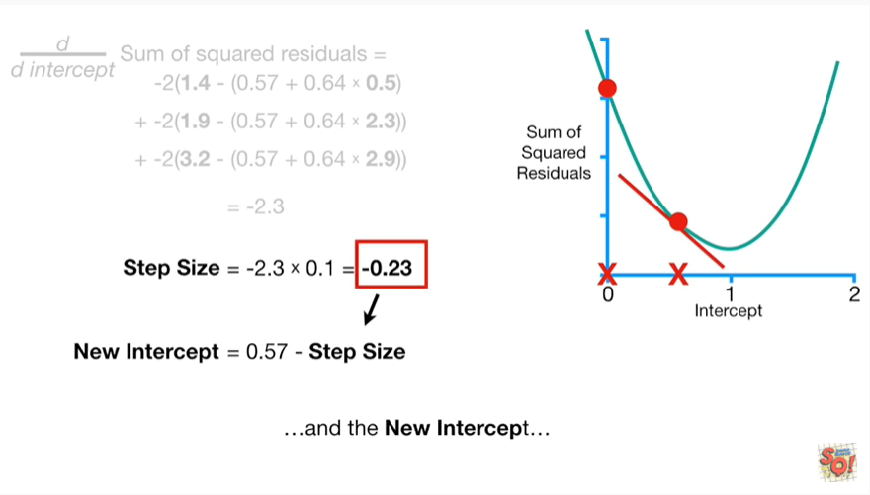

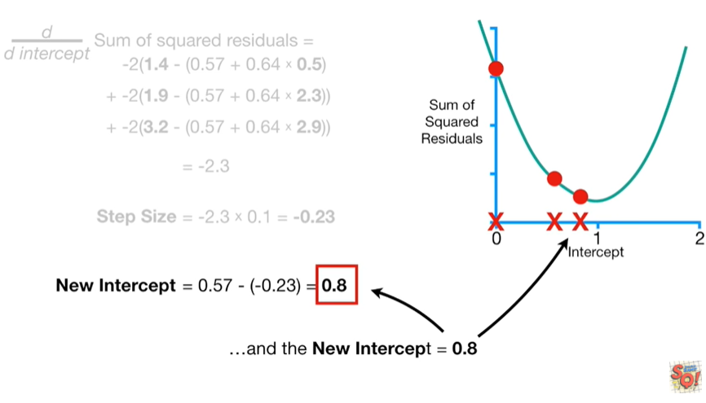

and the new intercept equals zero point eight.

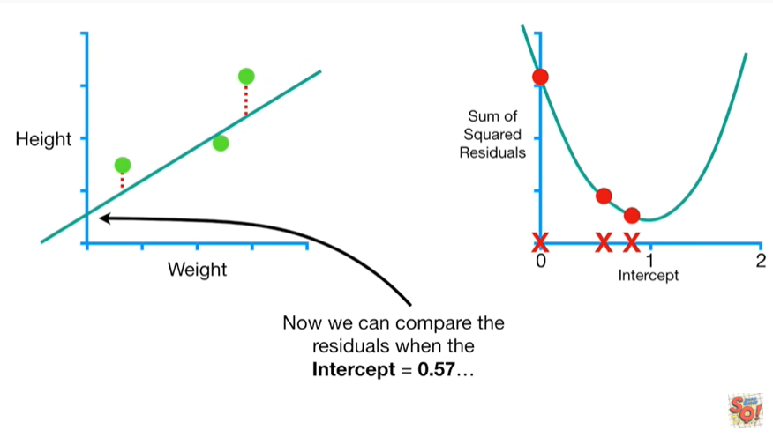

Now we can compare the residuals when the intercept equals zero point five seven

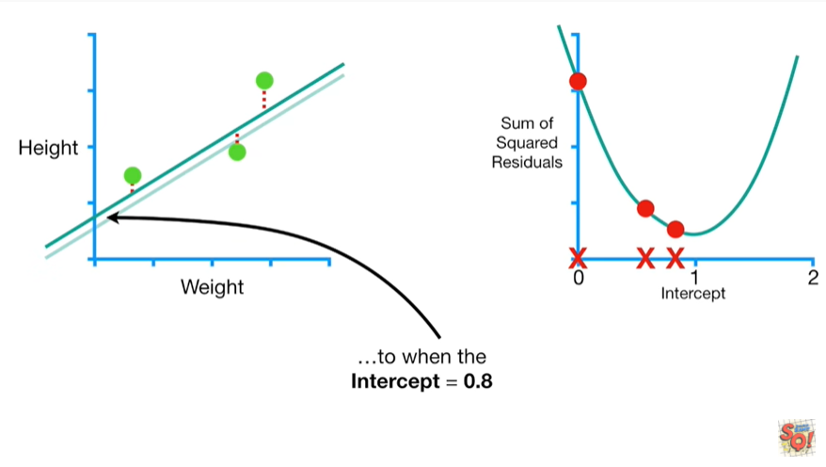

to when they intercept equals zero point eight.

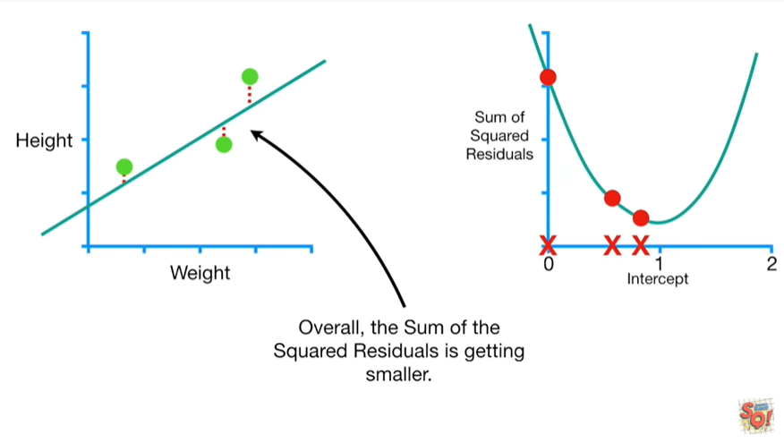

Overall, the sum of the squared residuals is getting smaller.

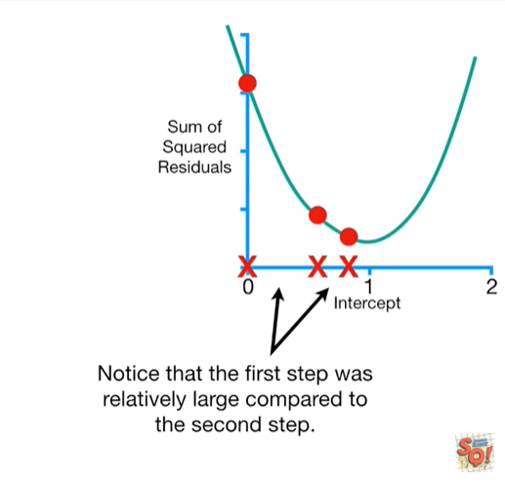

Notice that the first step was relatively large compared to the second step.

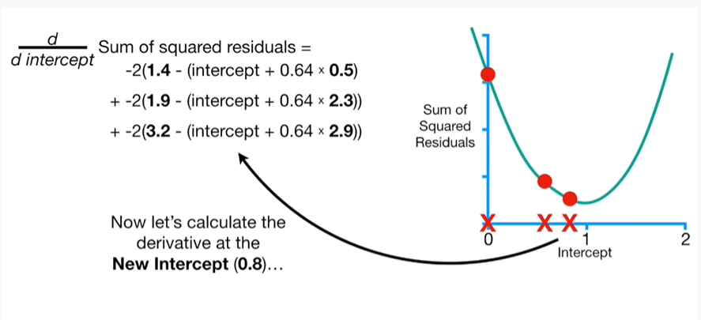

Now let's calculate the derivative at the new intercept

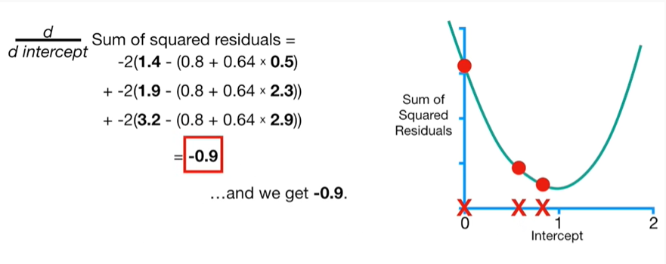

and we get negative zero point nine

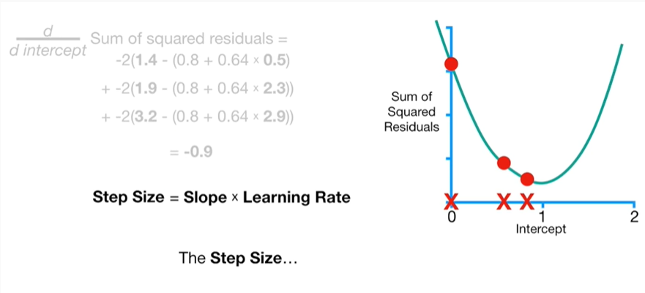

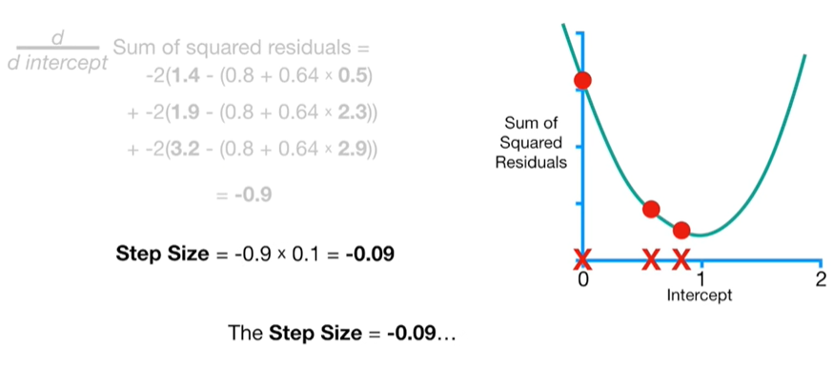

the step size equals negative zero point zero nine

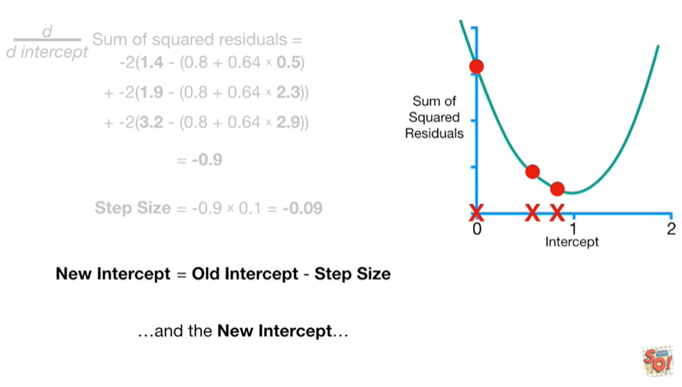

and the new intercept

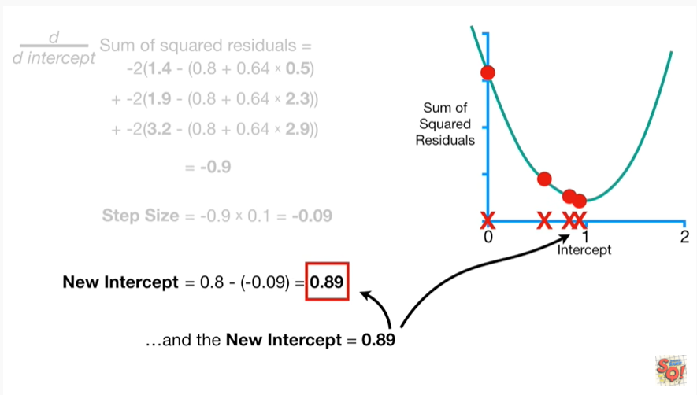

equals zero point eight nine.

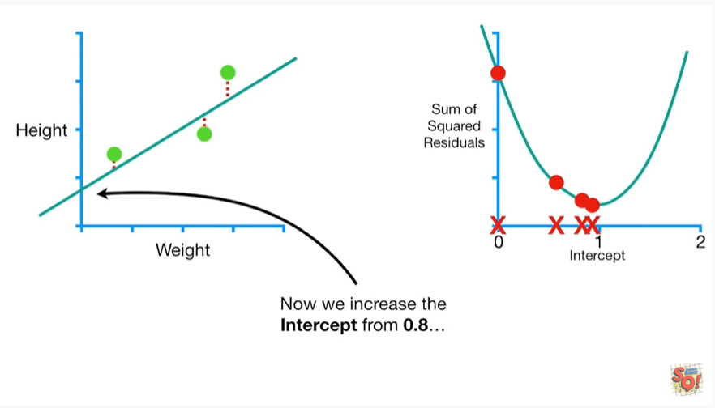

Now we increase the intercept from zero point eight

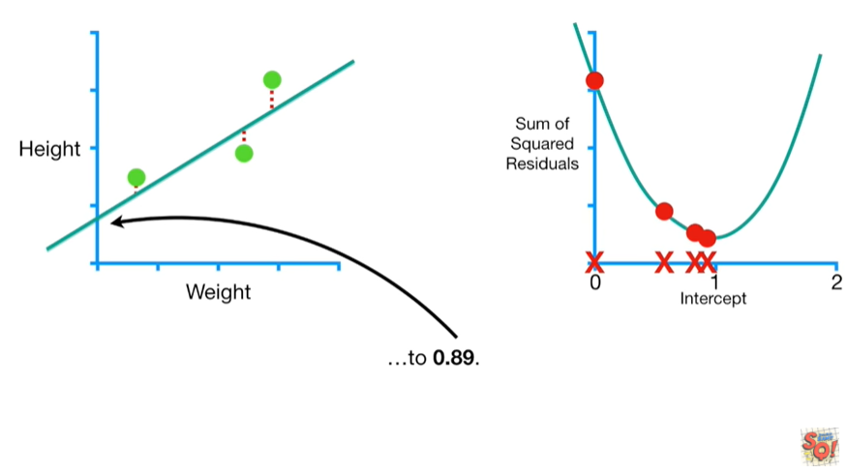

to zero point eight nine.

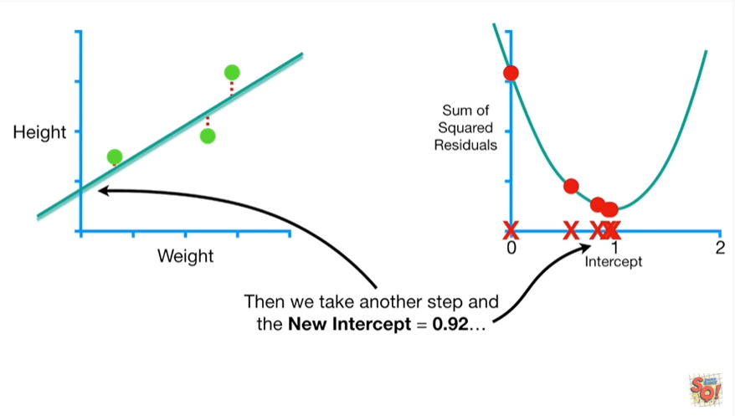

Then we take another step and the new intercept equals zero point nine two

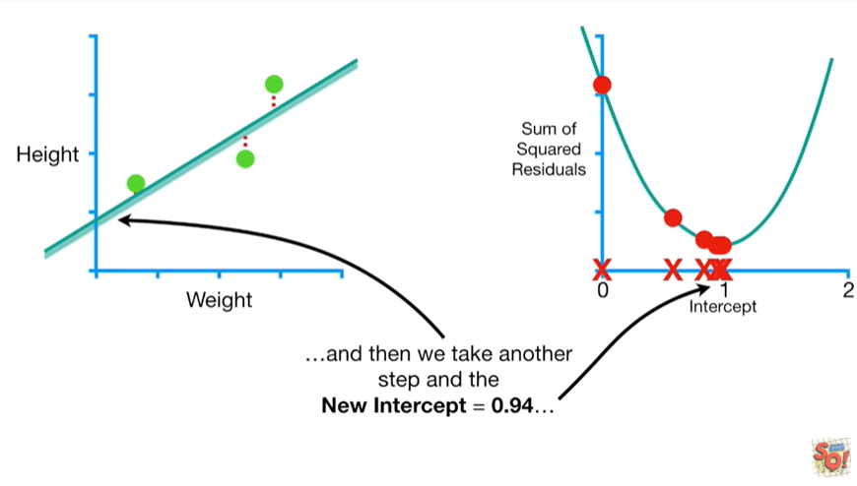

and then we take another step and the new intercept equals zero point nine four

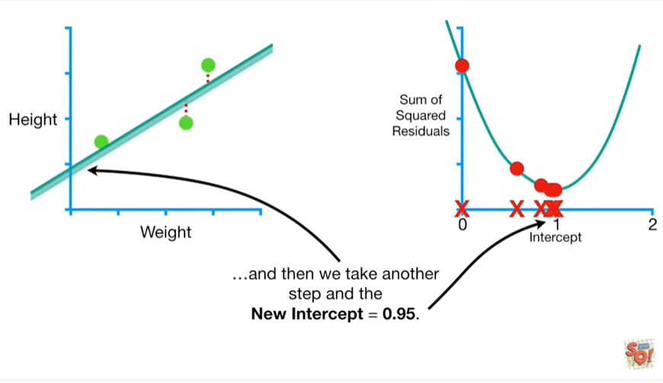

and then we take another step and the new intercept equals zero point nine five.

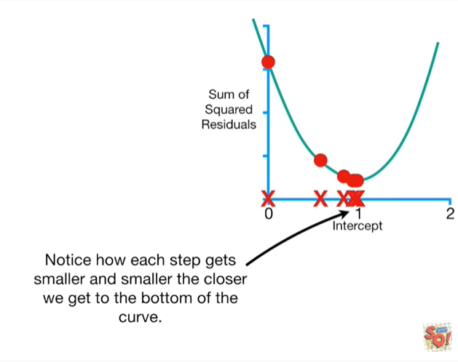

Notice how each step gets smaller and smaller the closer we get to the bottom of the curve.

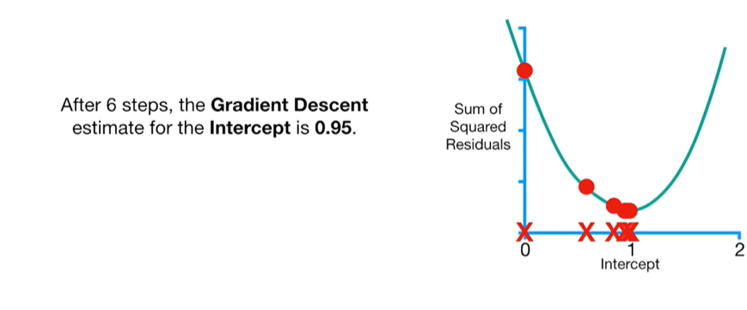

After six steps, the gradient descent estimate for the intercept is zero point nine five.

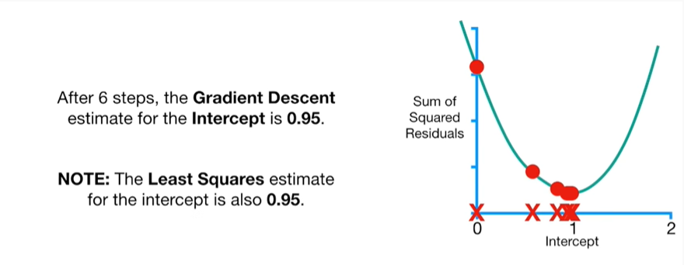

Note the least squares estimate for the intercept is also zero point nine five.

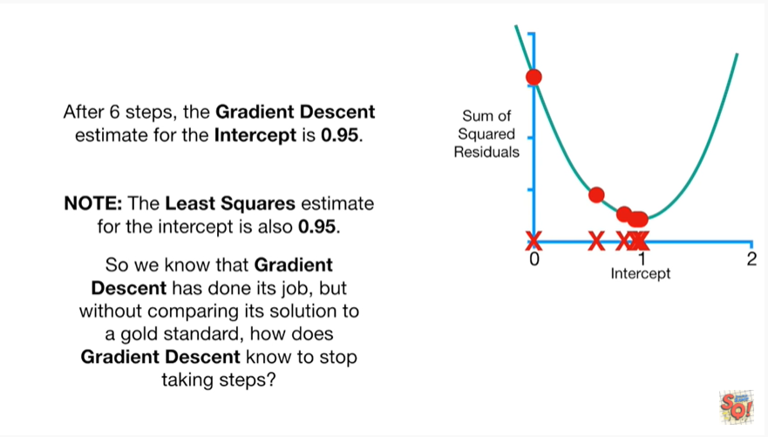

So we know that gradient descent has done its job, but without comparing its solution to a gold standard, how does gradient descent know to stop taking steps ?

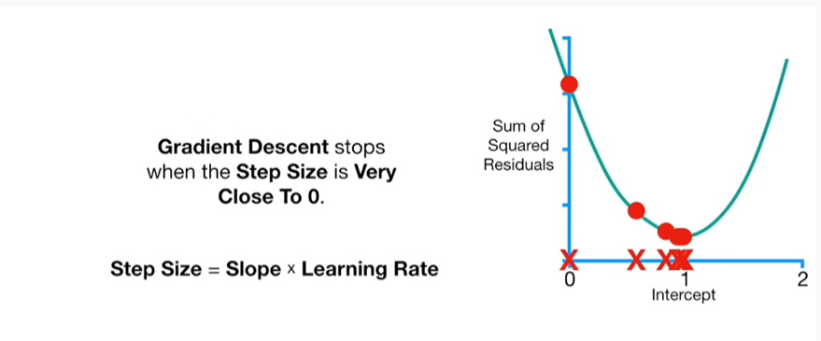

Gradient descent stops when the step size is very close to zero.

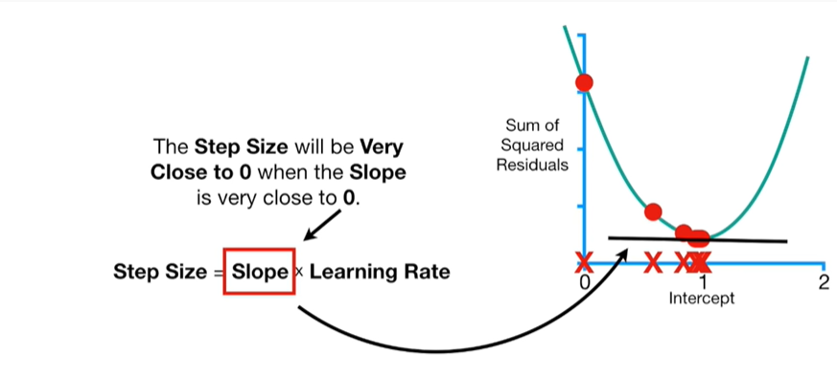

The step size will be very close to zero when the slope is very close to zero.

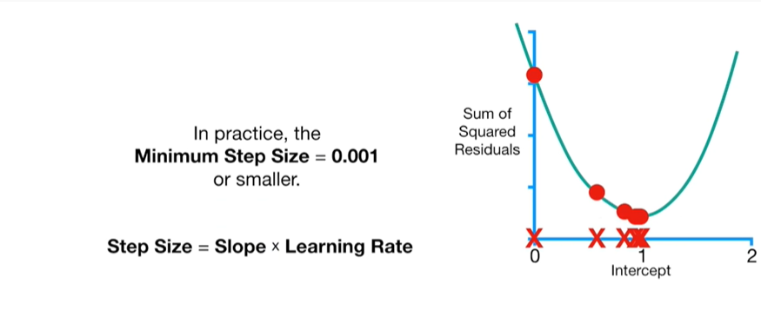

In practice the minimum step size equals 0.001 or smaller.

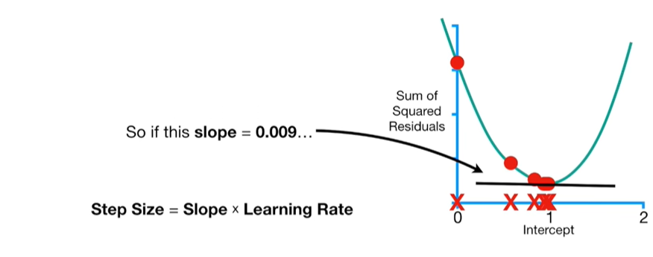

So if this slope equals zero point zero zero nine

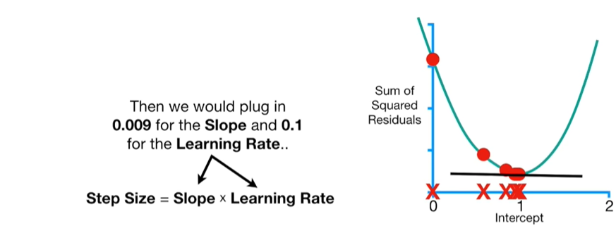then we would plug in zero point zero zero nine for the slope and zero point one for the learning rate

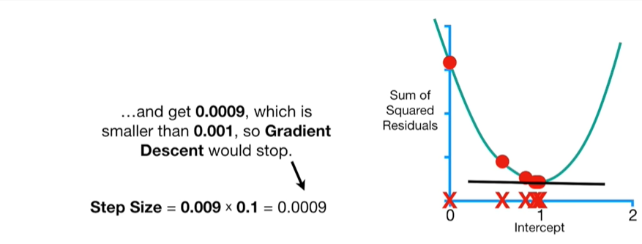

and get zero point zero zero zero nine, which is smaller than zero point zero zero one, so gradient descent would stop.

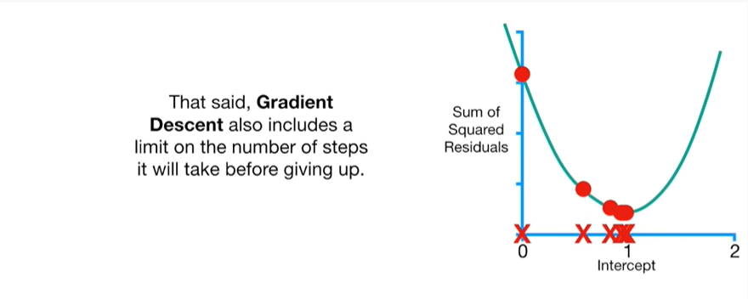

That said, gradient descent also includes a limit on the number of steps it will take before giving up.

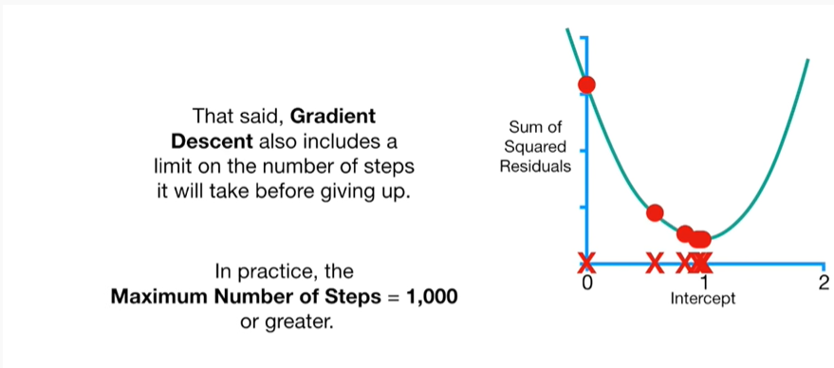

In practice, the maximum number of steps equals one thousand or greater.

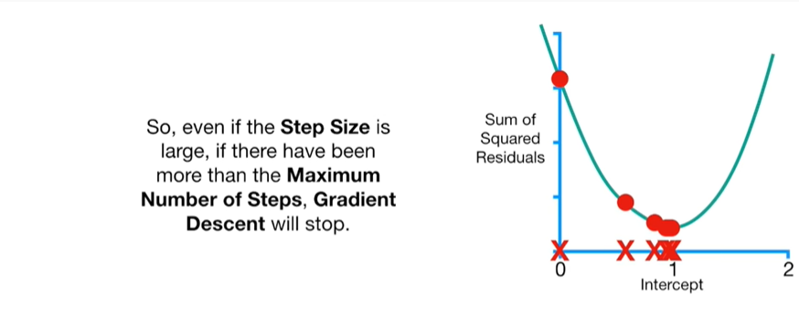

So, even if the step size is large if there have been more than a maximum number of steps gradient descent will stop.

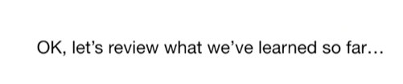

Okay let's review what we've learned so far.

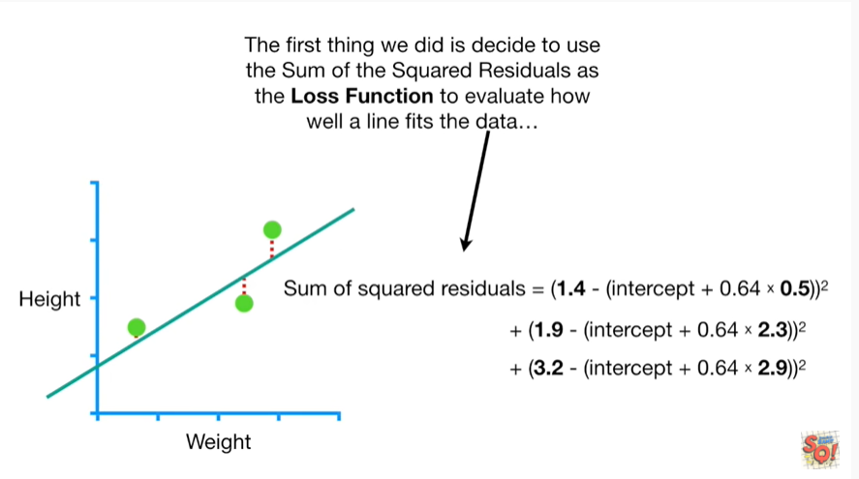

The first thing we did is decide to use the sum of the squared residuals as the loss function to evaluate how well a line fits the data

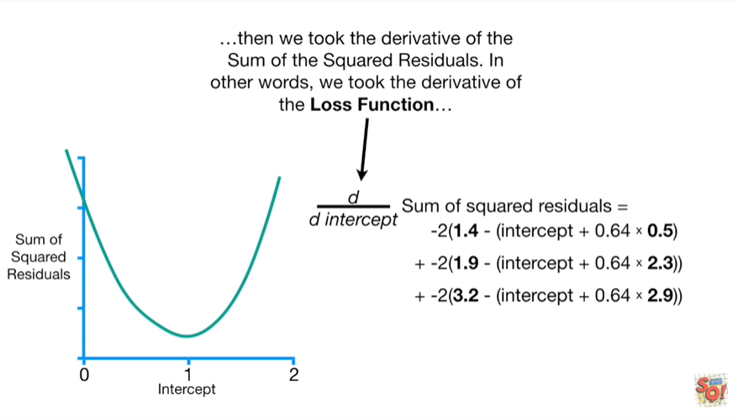

then we took the derivative of the sum of the squared residuals.

In other words we took the derivative of the loss function

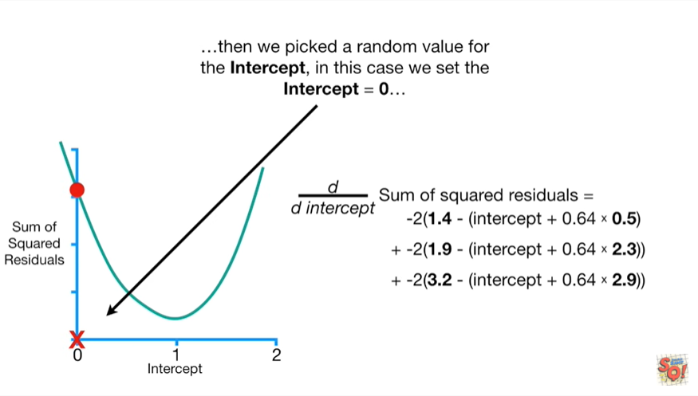

then we picked a random value for the intercept in this case we set the intercept to be equal to zero

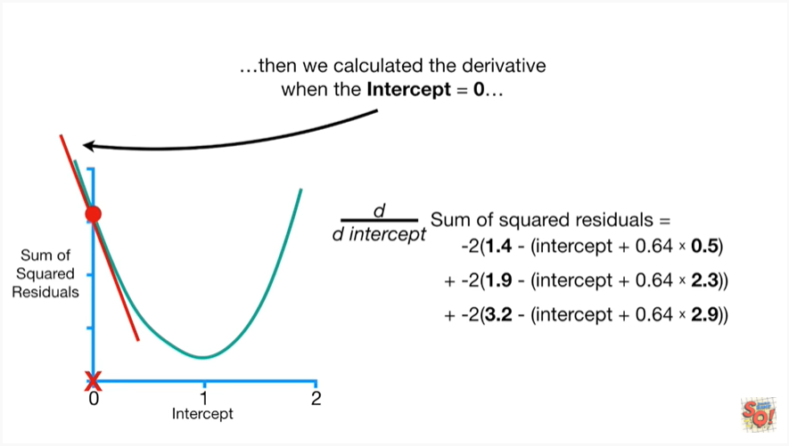

then we calculated the derivative when the intercept equals zero

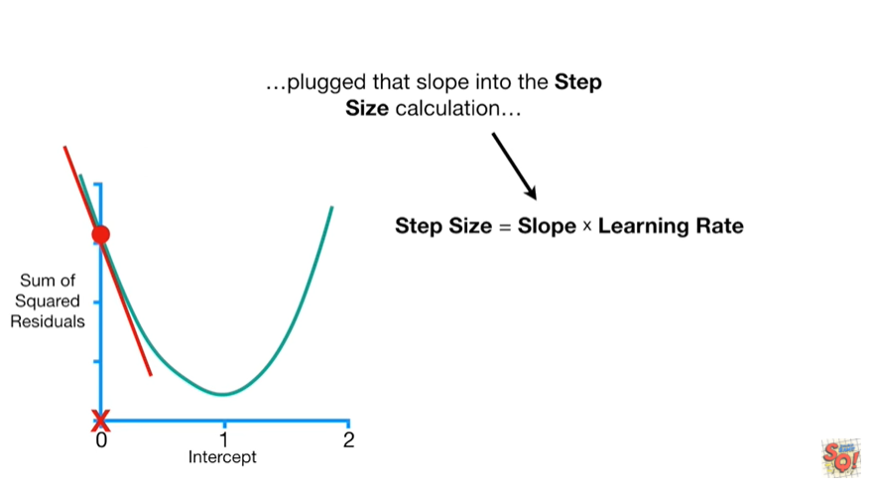

plug that slope into the step size calculation

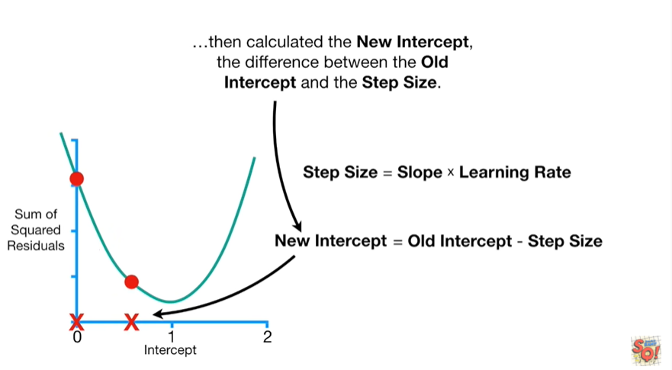

and then calculated the new intercept the difference between the old intercept and the step size.

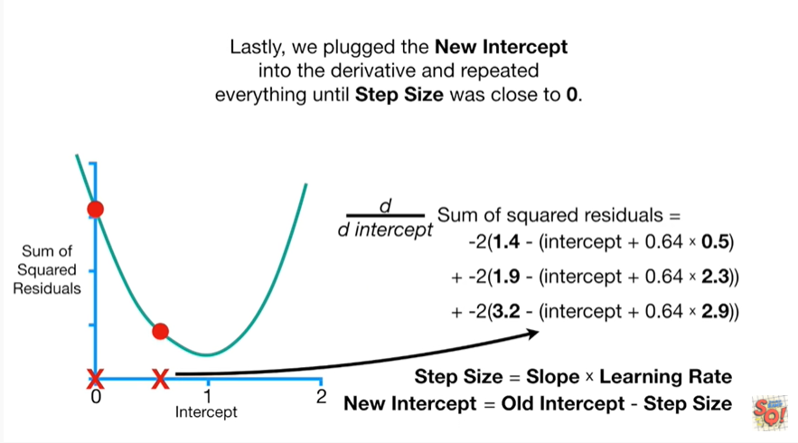

Lastly, we plug the new intercept into the derivative and repeated everything until step size was close to zero.

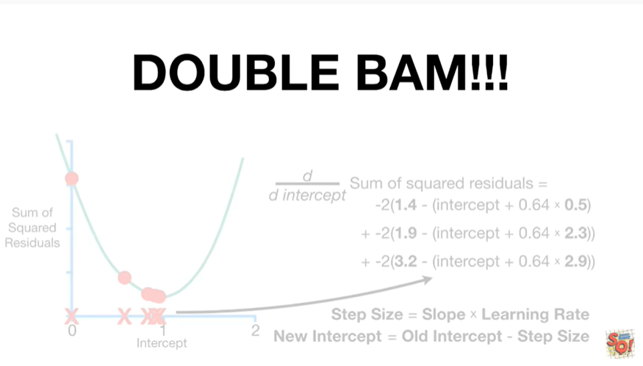

Double bam !!!

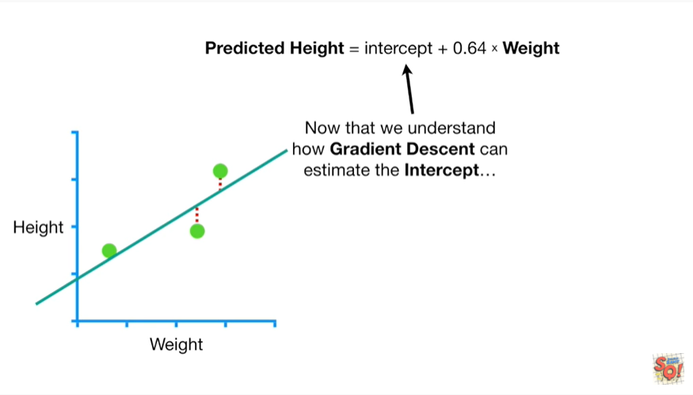

Now that we understand how gradient descent can calculate the intercept

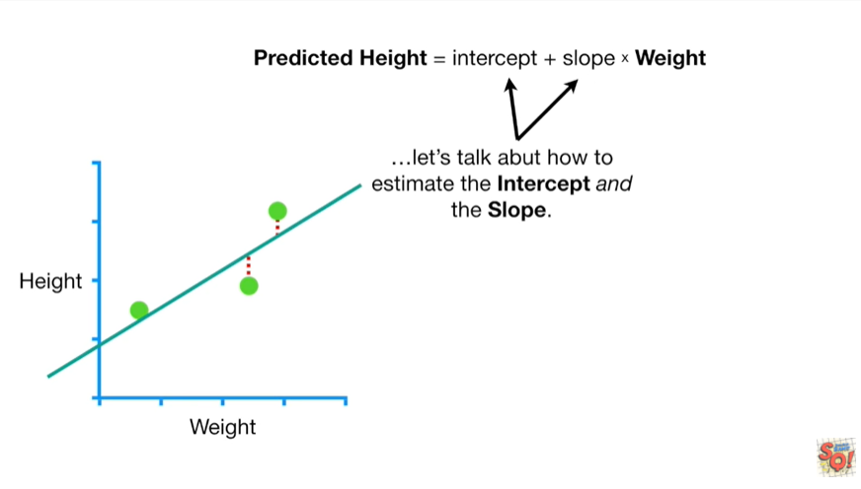

let's talk about how to estimate the intercept and the slope.

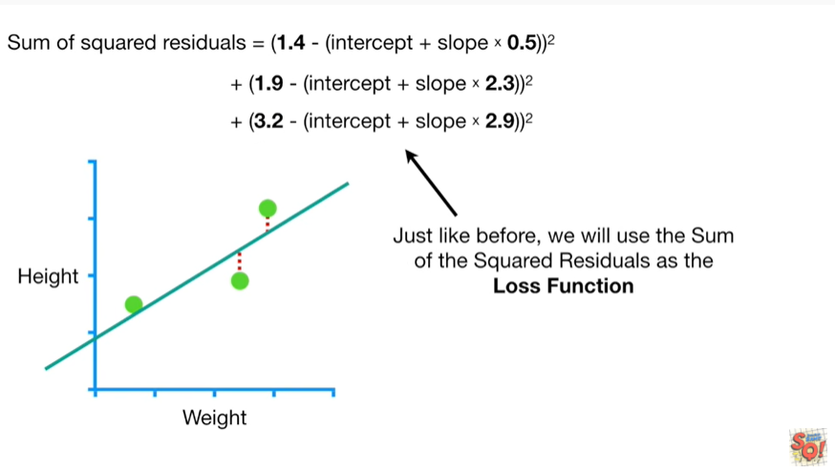

Just like before we'll use the sum of the squared residuals as the loss function.

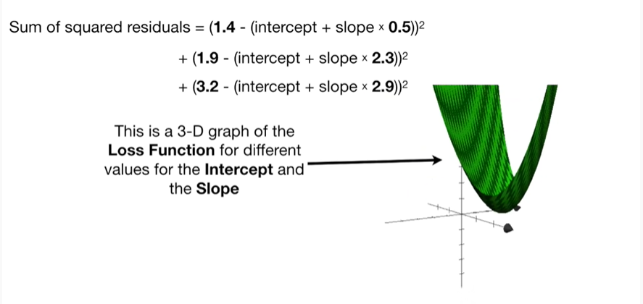

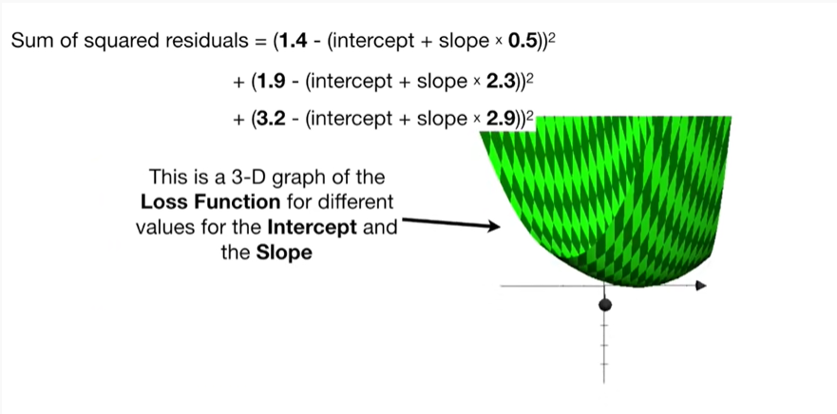

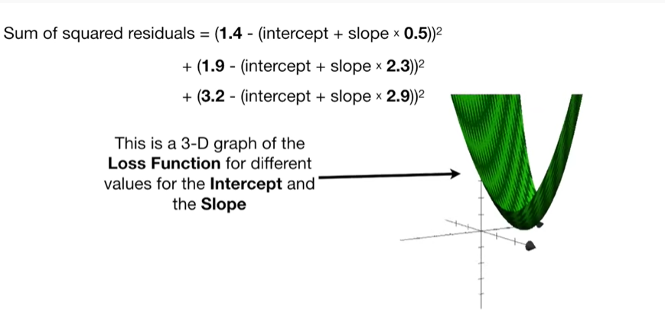

This is a 3d graph of the loss function for the different values for the intercept and the slope.

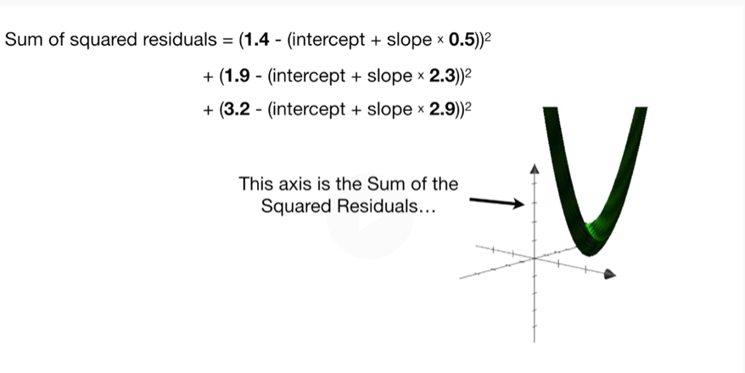

This axis is the sum of the squared residuals

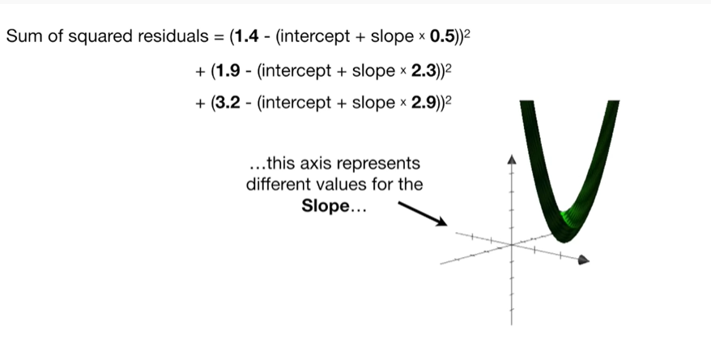

this axis represents different values for the slope

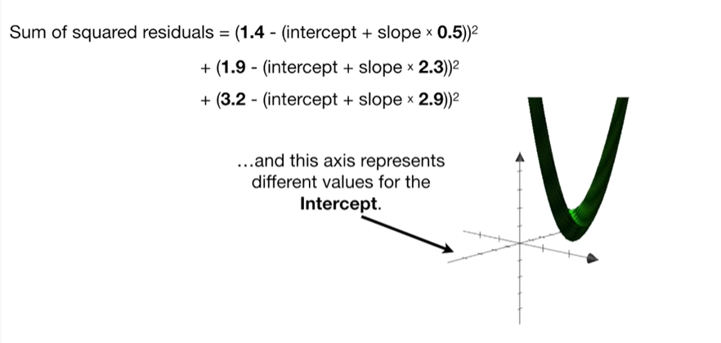

and this access represents different values for the intercept.

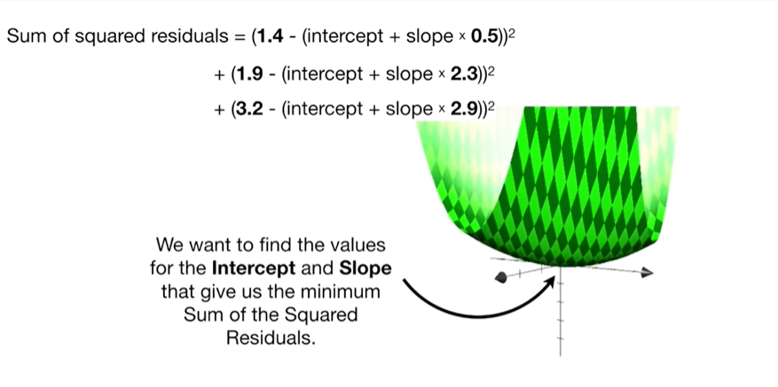

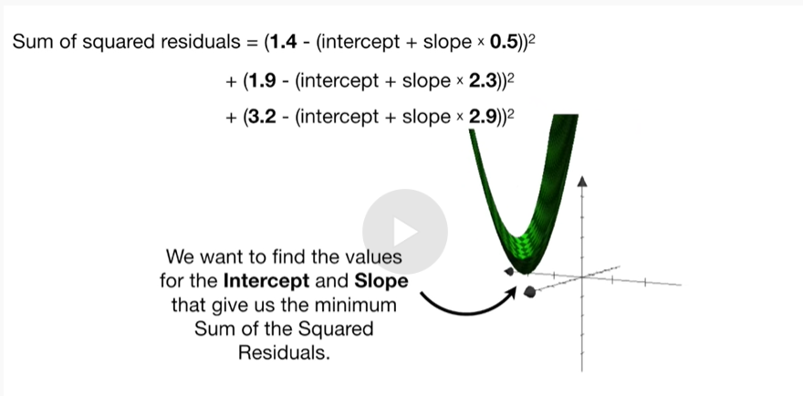

We want to find the values for the intercept and slope that give us the minimum sum of the squared residuals.

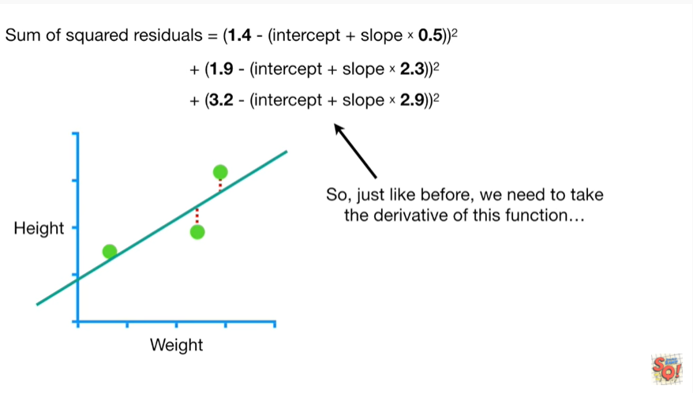

So just like before we need to take the derivative of this function

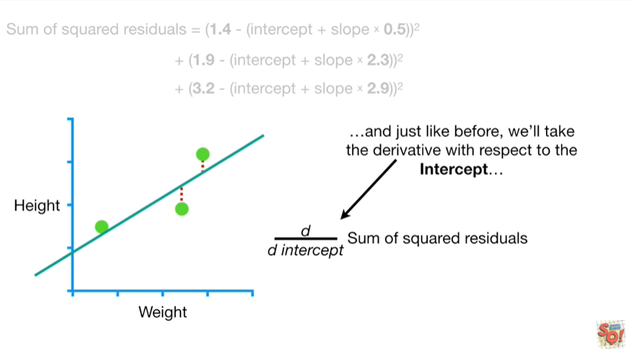

and just like before we'll take the derivative with respect to the intercept

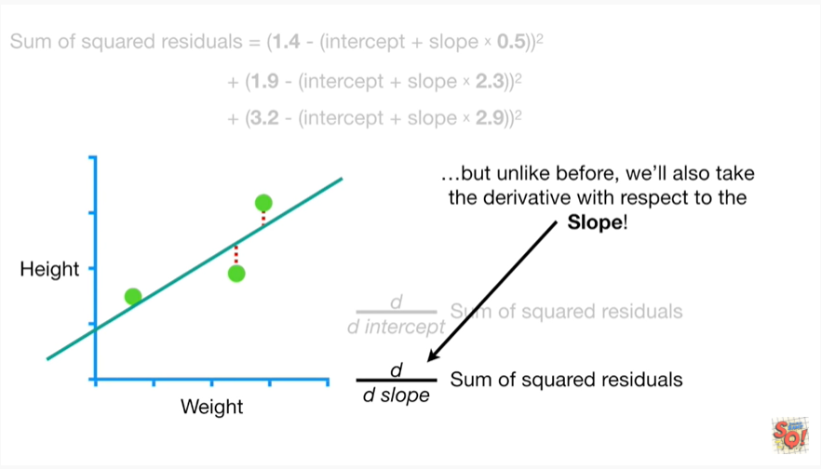

but unlike before we'll also take the derivative with respect to the slope !

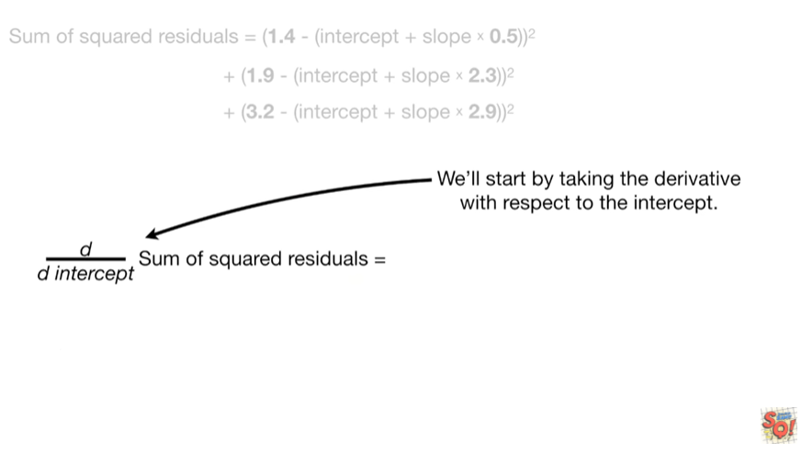

We'll start by taking the derivative with respect to the intercep.

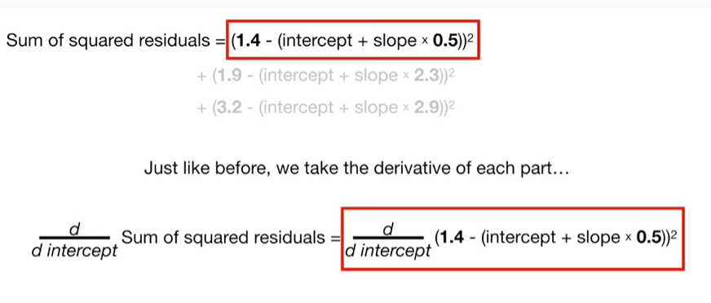

Just like before we'll take the derivative of each part

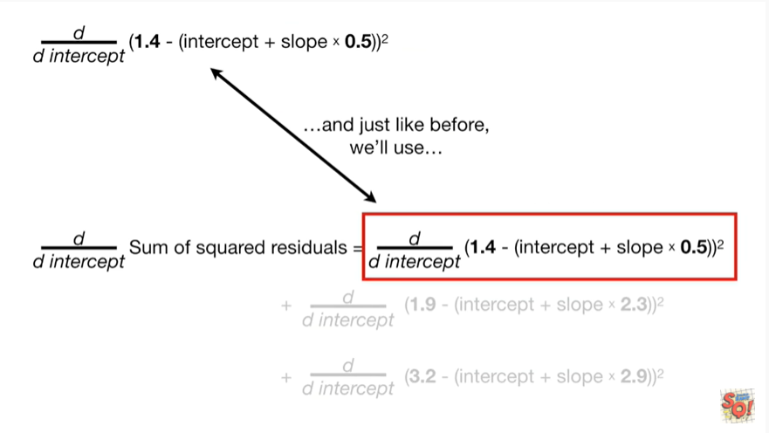

and just like before we'll use



the chain rule

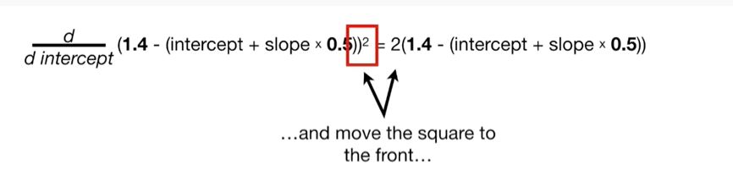

and move the square to the front

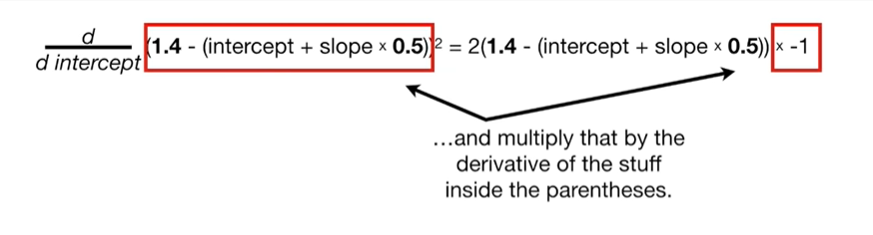

and multiply that by the derivative of the stuff inside the parenthesis.

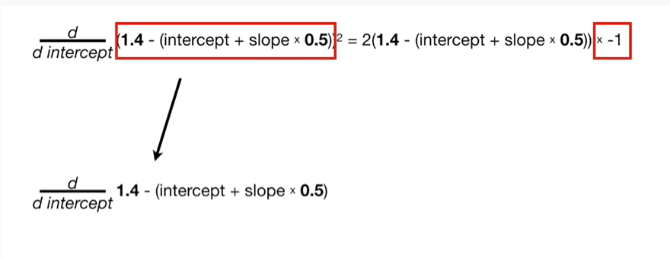

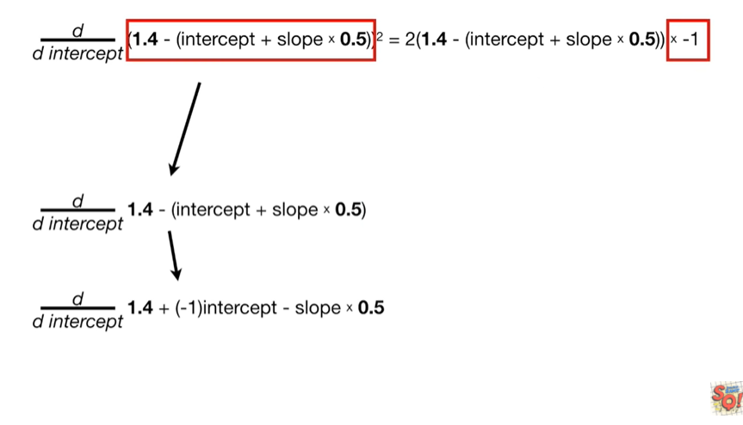

boo-boo-boo-boo-boo.

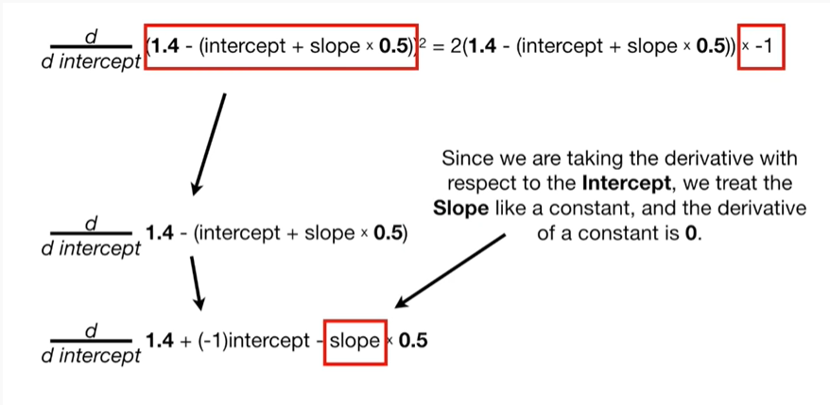

Since we are taking the derivative with respect to the intercept, we treat the slope like a constant and the derivative of a constant is zero.

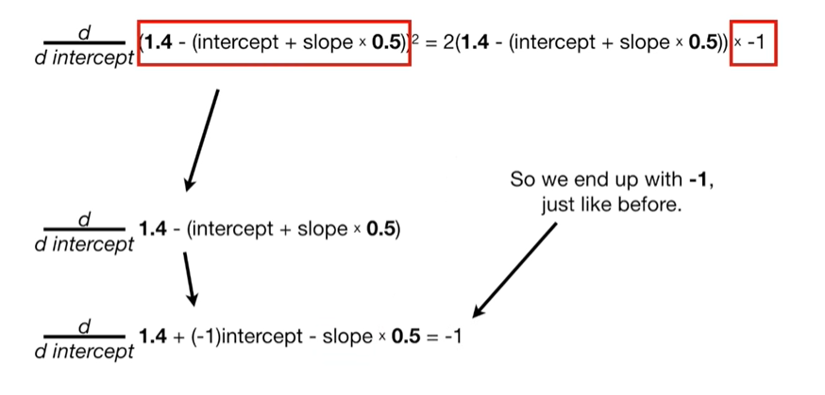

So we end up with negative one just like before.

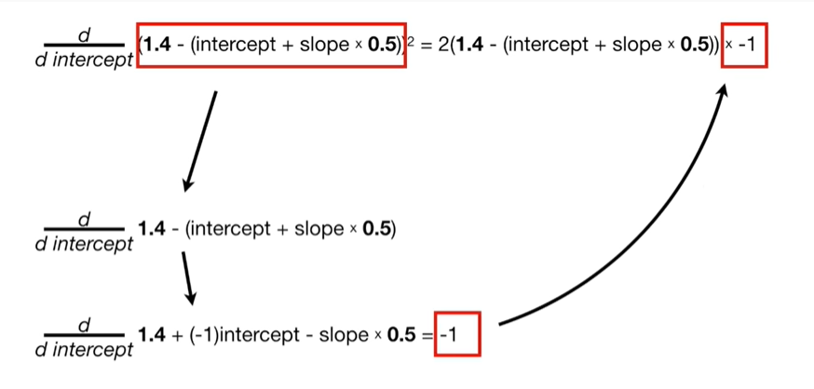

Bee boo.

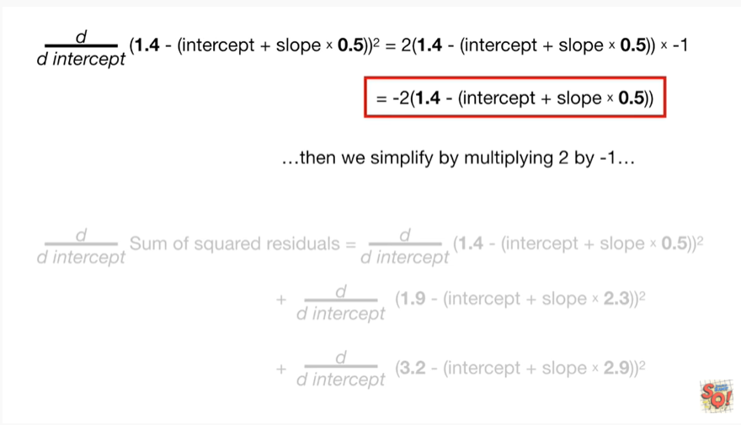

Then we simplify by multiplying two by negative one

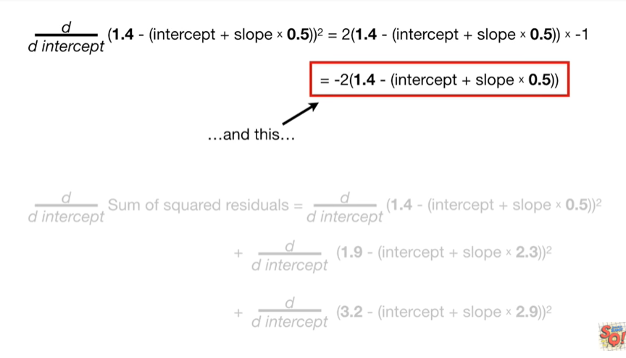

and this

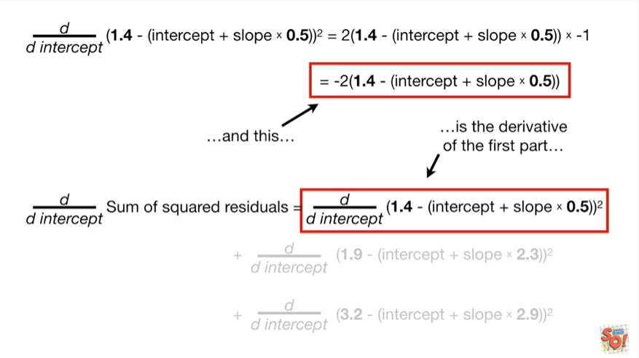

is the derivative of the first part

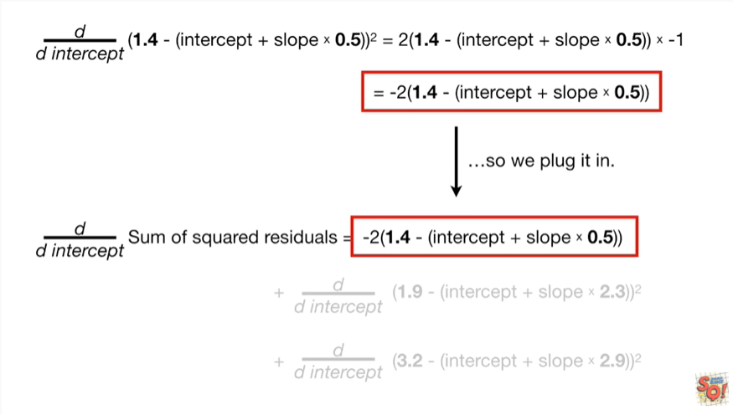

so we plug it in.

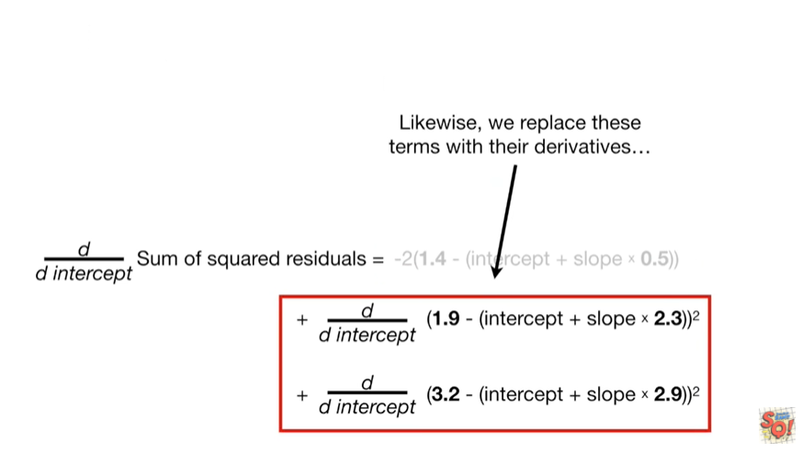

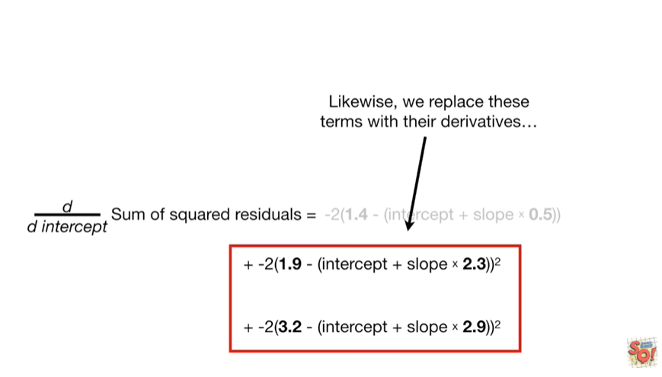

Likewise, we replace these terms with their derivatives

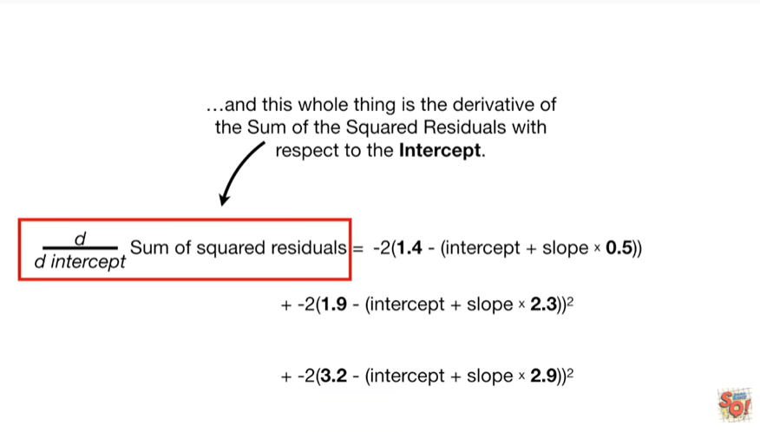

So this whole thing is the derivative of the sum of squared residuals with respect to the intercept.

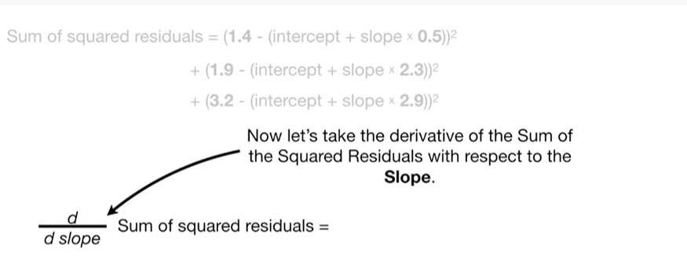

Now let's take the derivative of the sum of the squared residuals with respect to the slope.

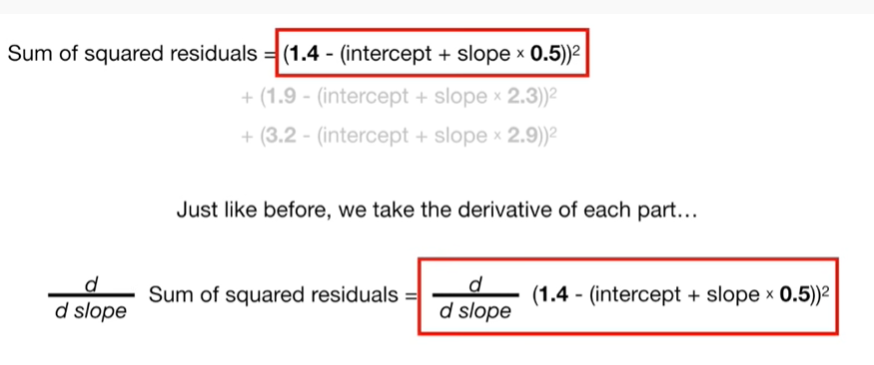

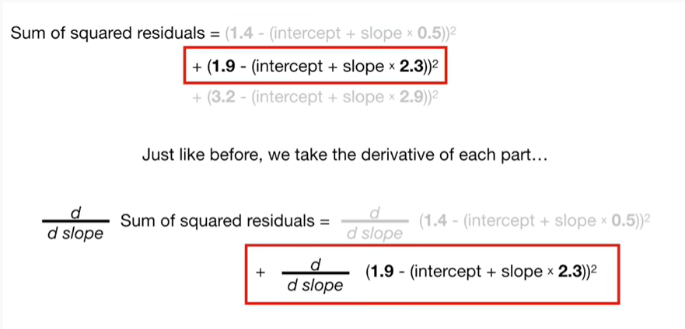

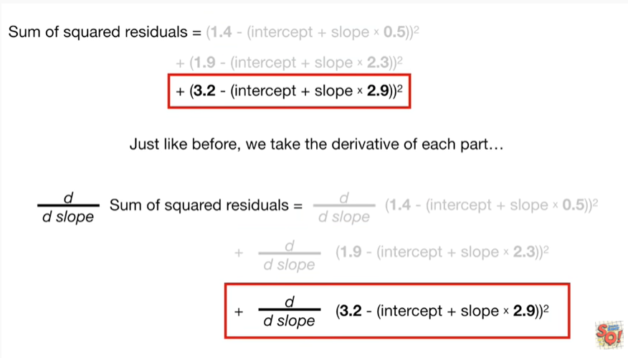

Just like before we take the derivative of each part

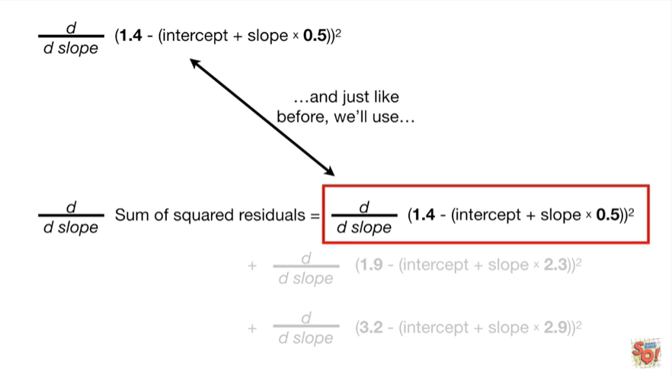

and just like before we'll use



the chain rule

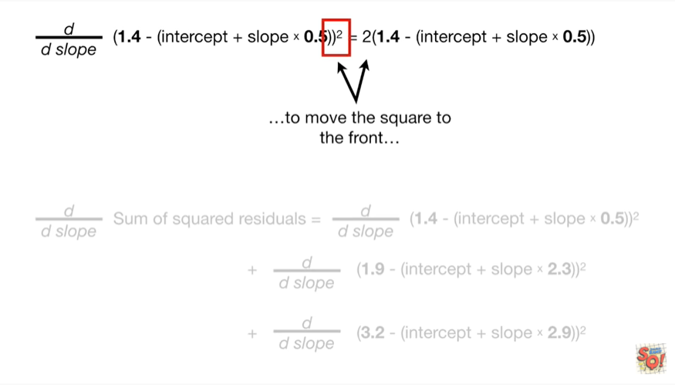

to move the square to the front

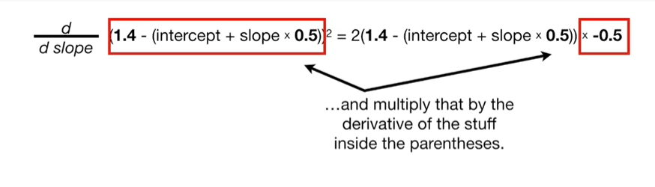

and multiply that by the derivative of the stuff inside the parenthesis

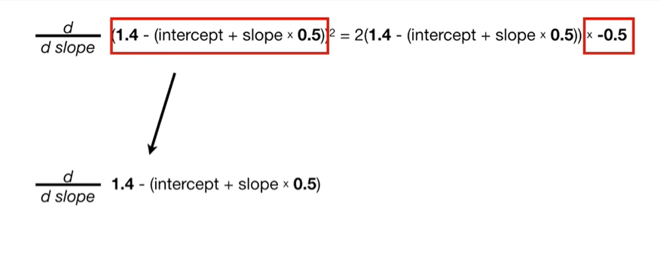

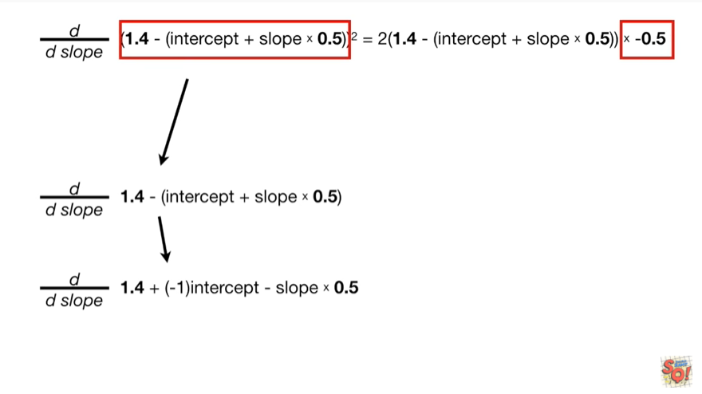

be boo boo boo Boop.

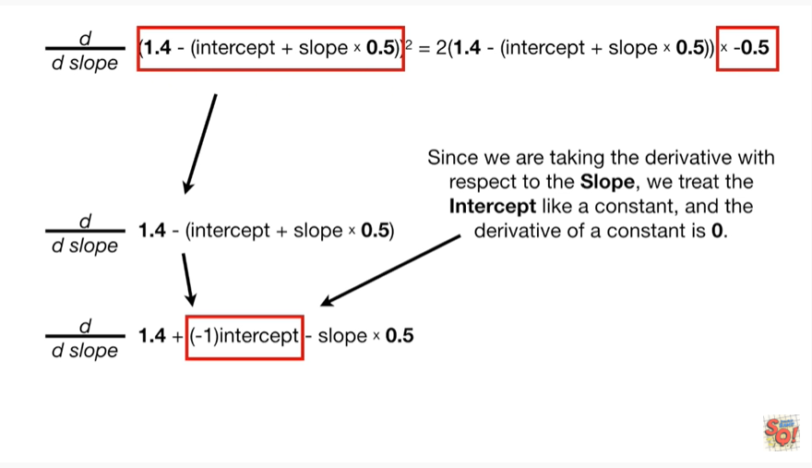

Since we are taking the derivative with respect to the slope, we treat the intercept like a constant, and the derivative of a constant is 0.

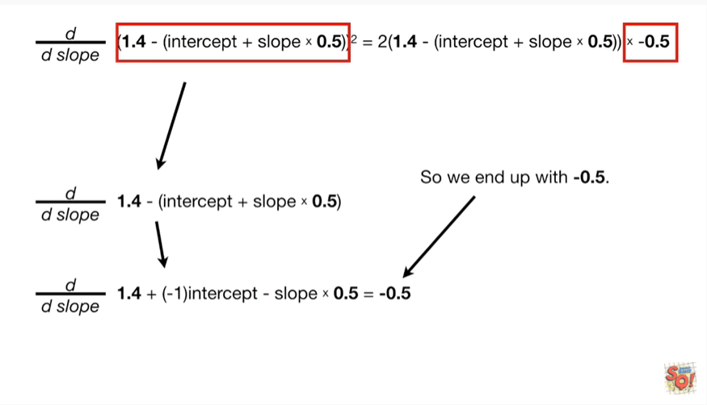

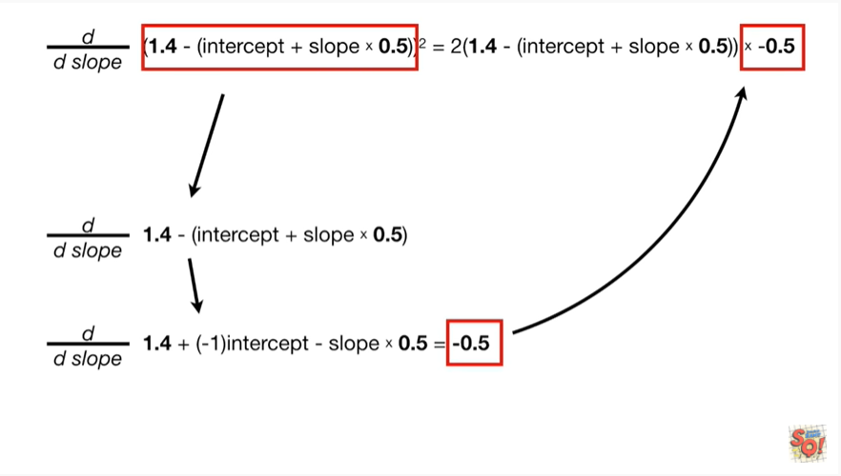

So we end up with negative 0.

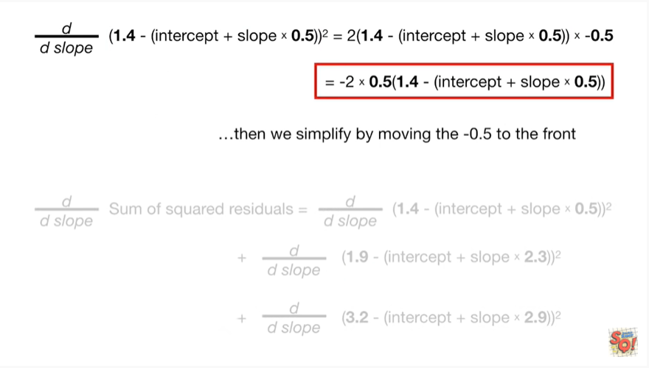

Then we simplify by moving the negative 0.5 to the front.

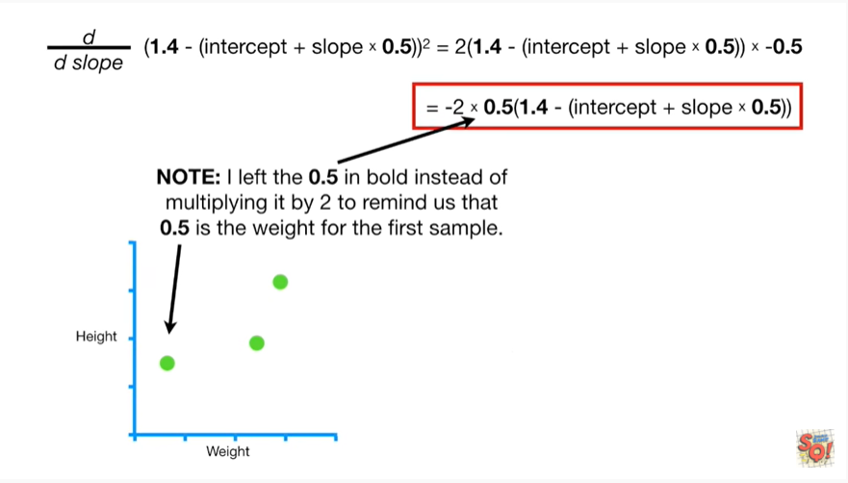

Note I left the 0.5 and bold instead of multiplying it by 2 to remind us that 0.5 is the weight for the first sample.

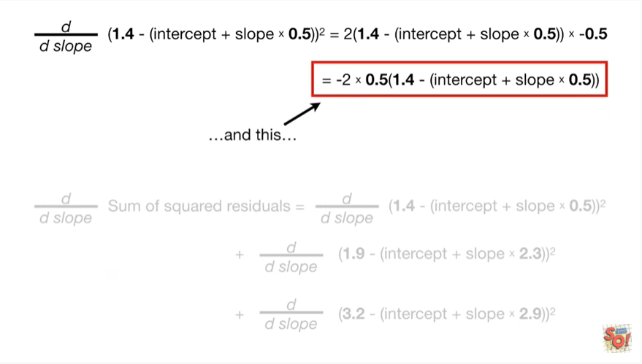

and this

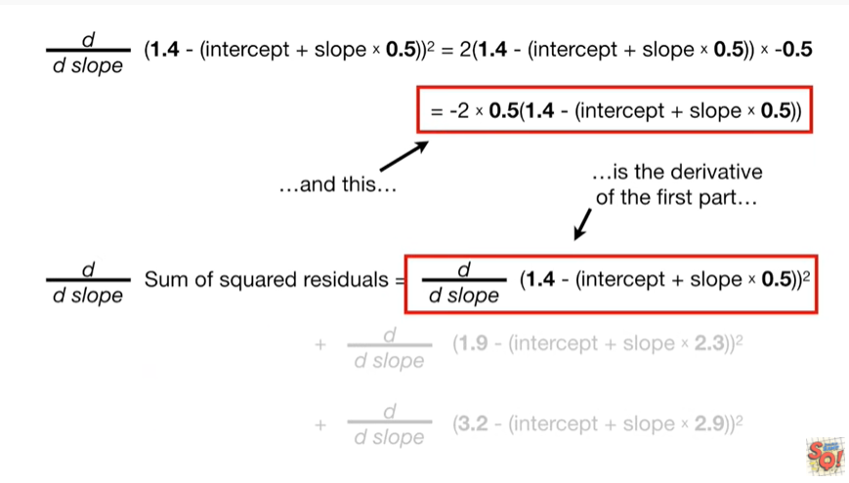

is the derivative of the first part

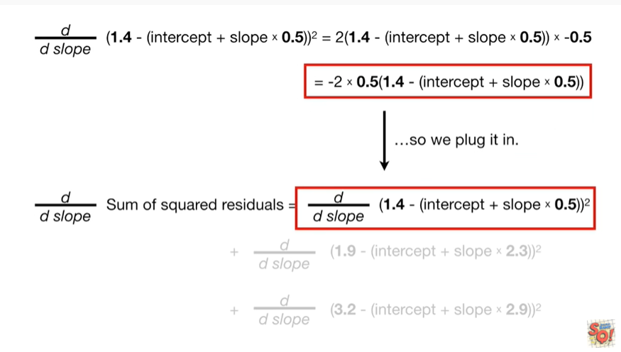

so we plug it in.

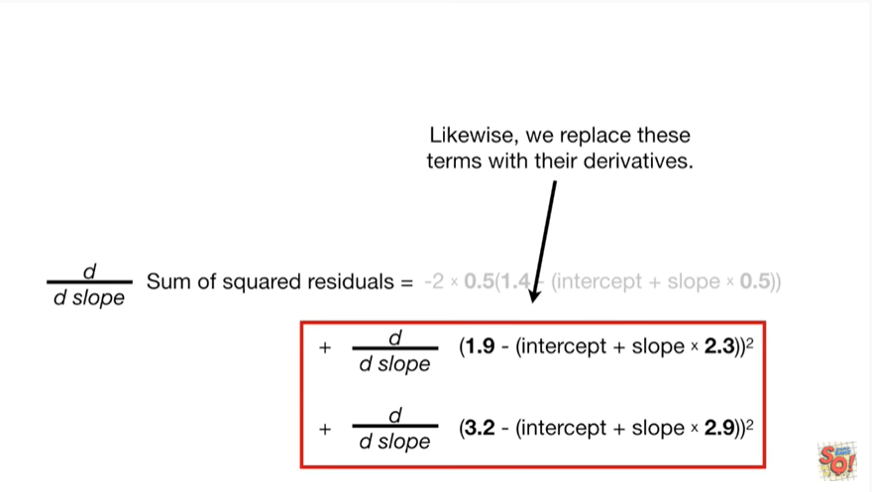

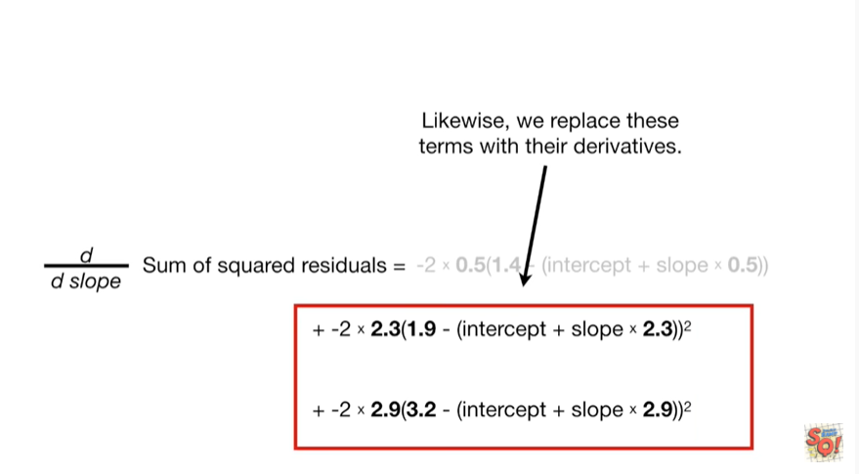

Likewise, we replace these terms with their derivatives.

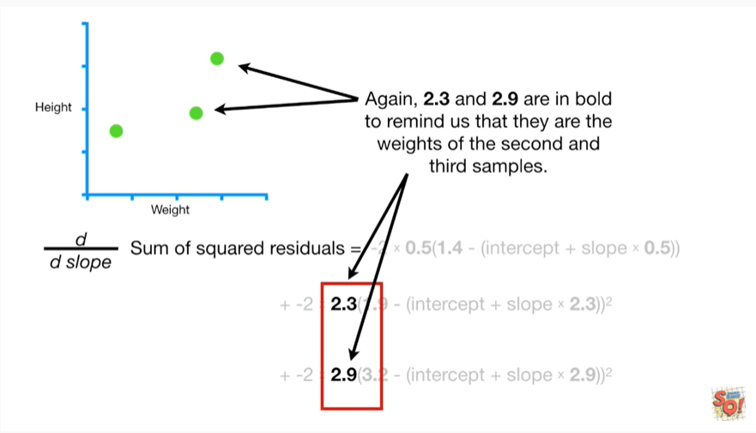

Again, two point three and two point nine are in bold to remind us that they are the weights of the second and third samples.

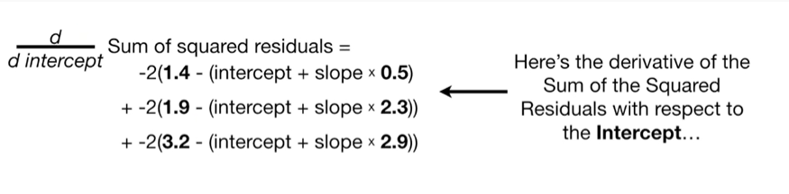

Here's the derivative of the sum of the squared residuals with respect to the intercept

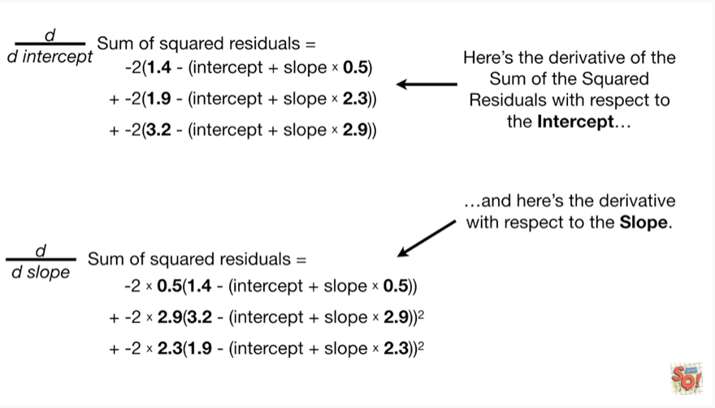

and here's the derivative with respect to the slope.

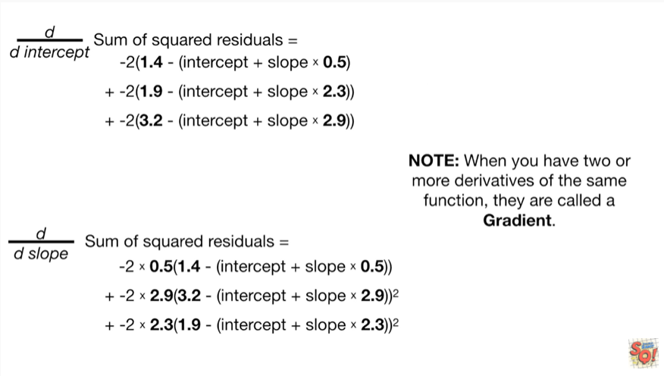

Note : when you have two or more derivatives of the same function they are called a gradient.

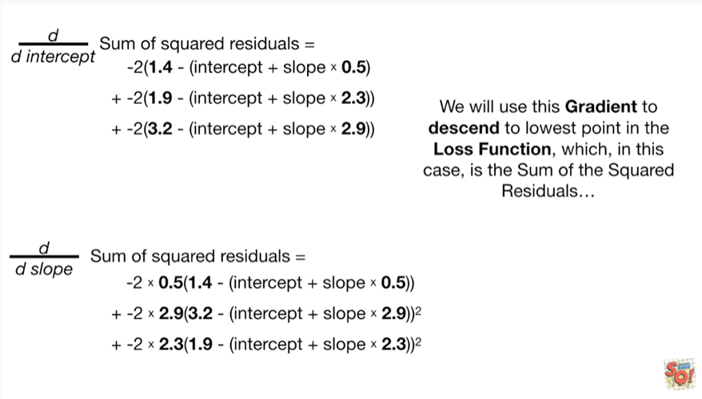

We will use this gradient to descend to the lowest point in the loss function, which, in this case, is the sum of the squared residuals

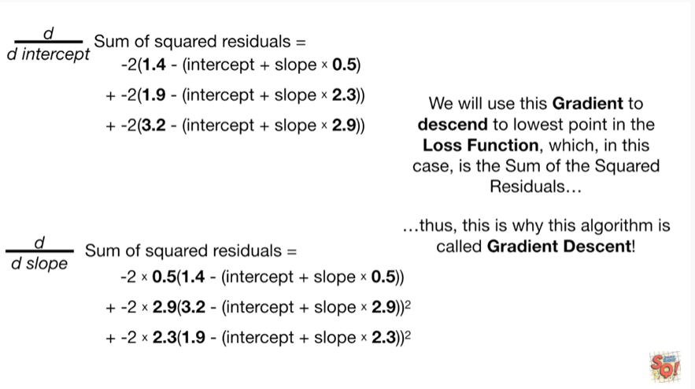

thus this is why the algorithm is called gradient descent !

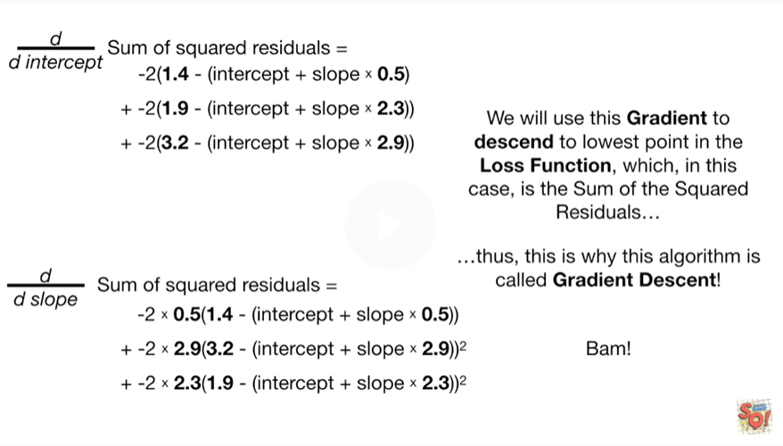

BAM !!!

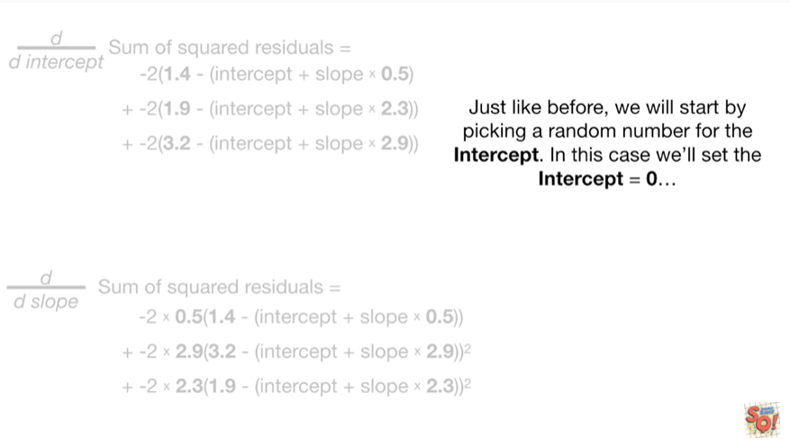

Just like before, we'll start by picking a random number for the intercept.

In this case, we'll set the intercept to be equal to zero

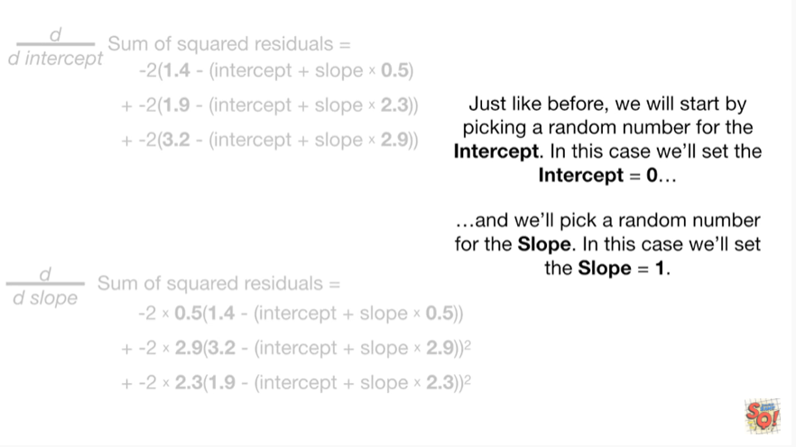

and we'll pick a random number for the slope.

In this case, we'll set the slope to be 1.

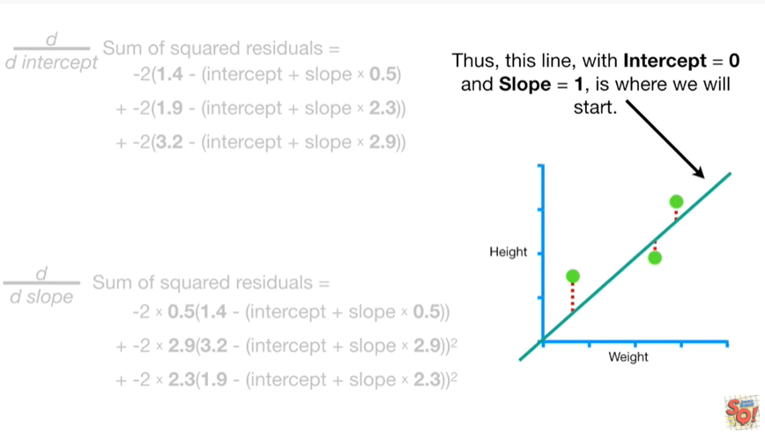

Thus this line with intercept equals 0 and slope equals 1, is where we will start.

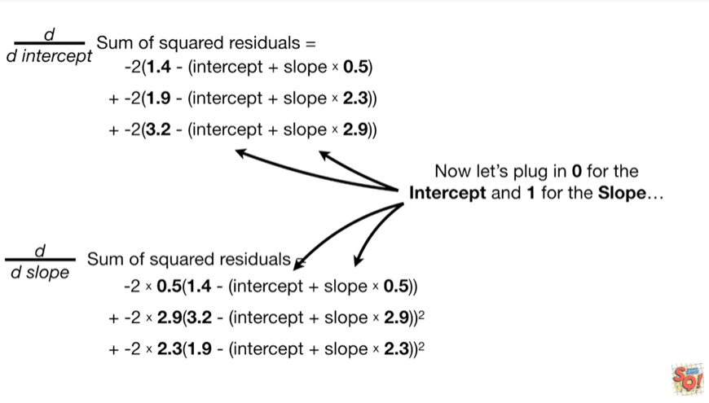

Now let's plug in 0 for the intercept and 1 for the slope

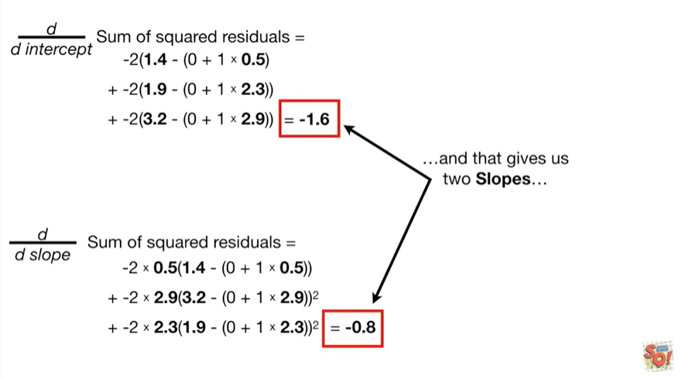

and that gives us two slopes

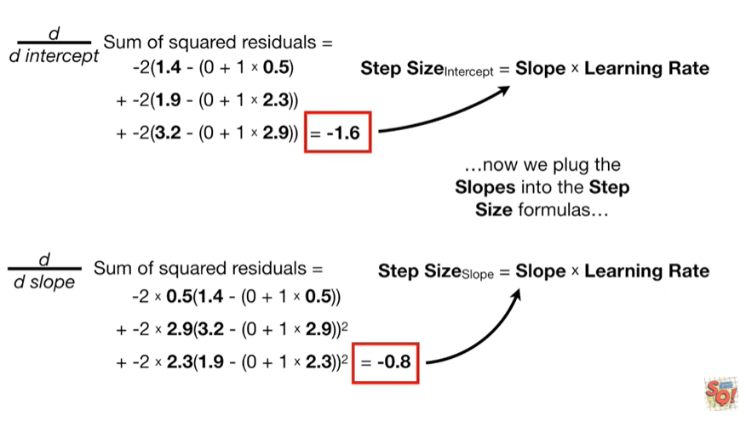

now we plug the slopes into the step size formulas

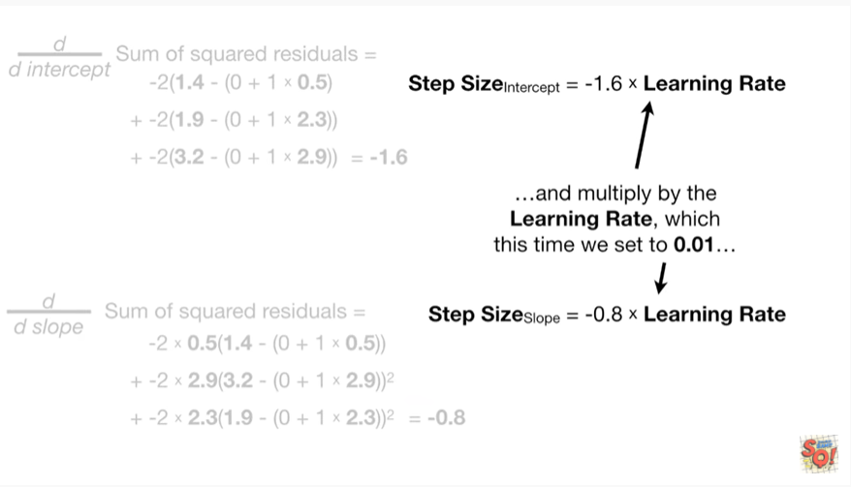

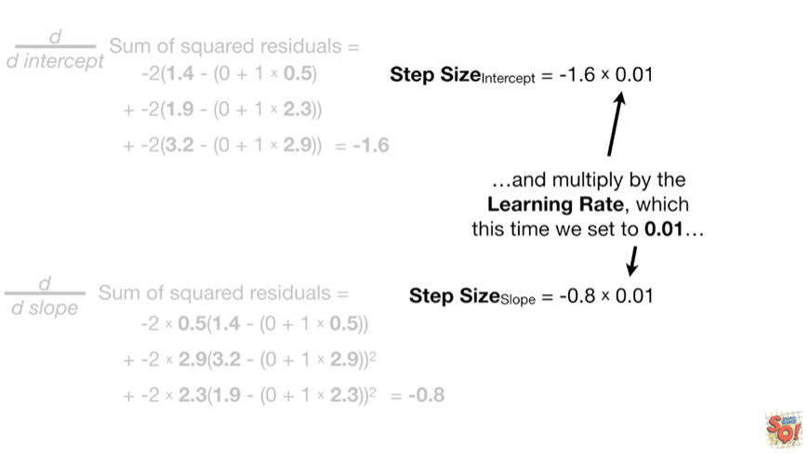

and multiply by the learning rate which this time we set to 0.01.

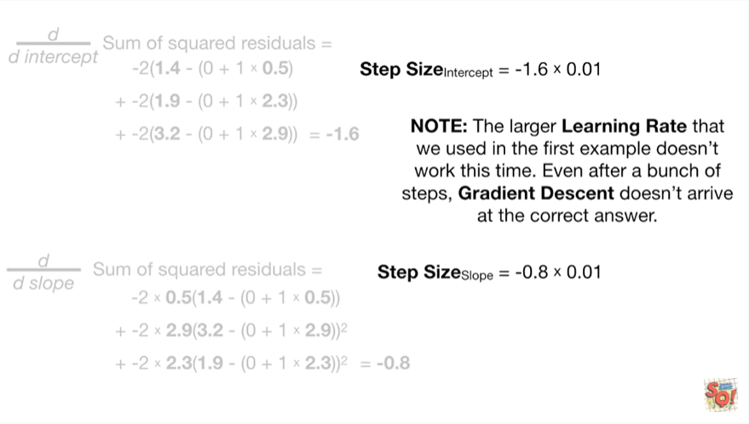

Note : the larger learning rate that we used in the first example doesn't work this time.

Even after a bunch of steps, gradient descent doesn't arrive at the correct answer.

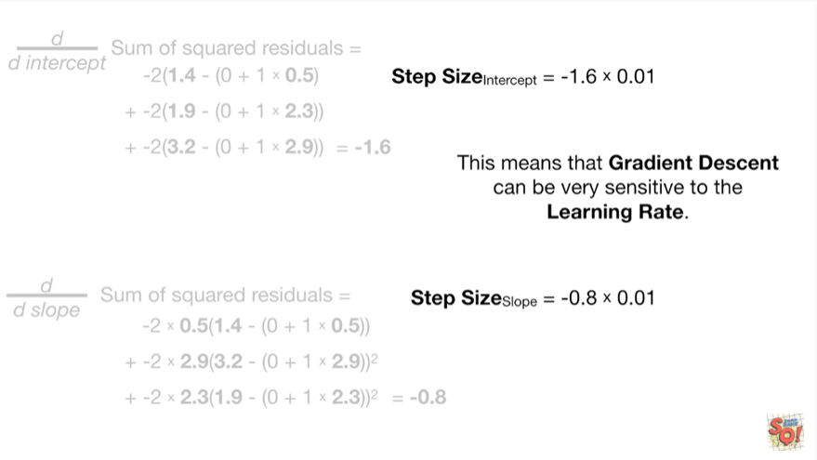

This means that gradient descent can be very sensitive to the learning rate.

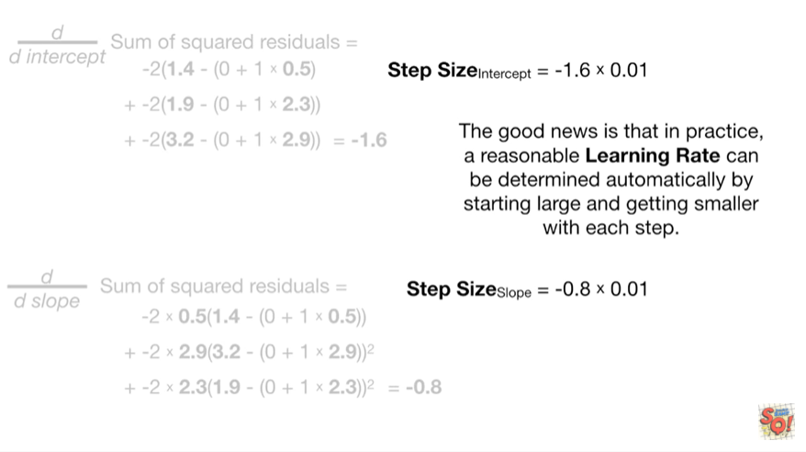

The good news is that in practice, a reasonable learning rate can be determined automatically by starting large and getting smaller with each step.

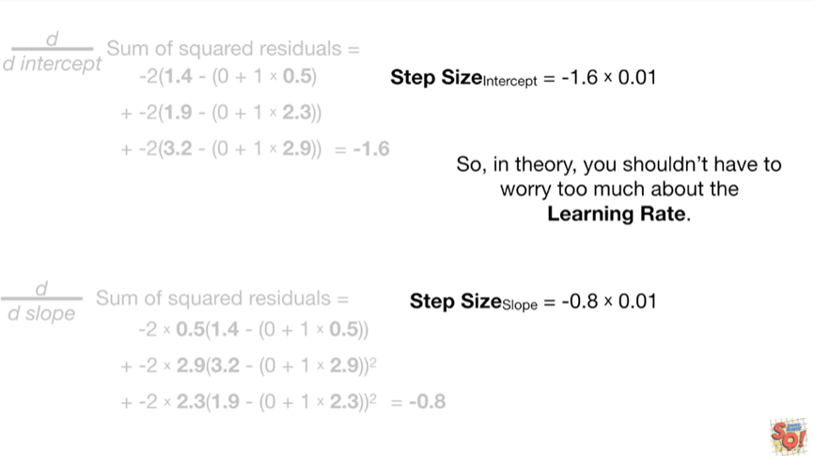

So in theory he shouldn't have to worry too much about the learning rate.

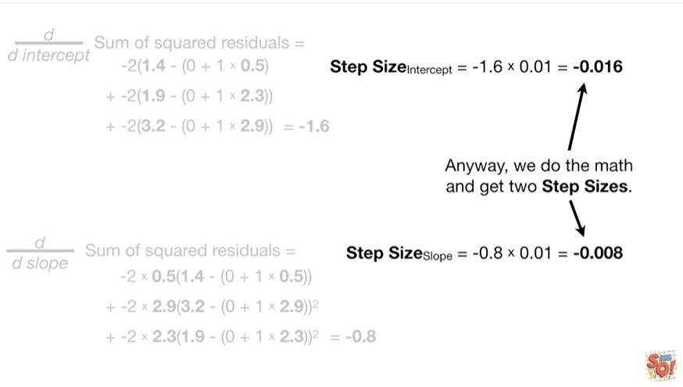

Anyway, we do the math and get to step sizes.

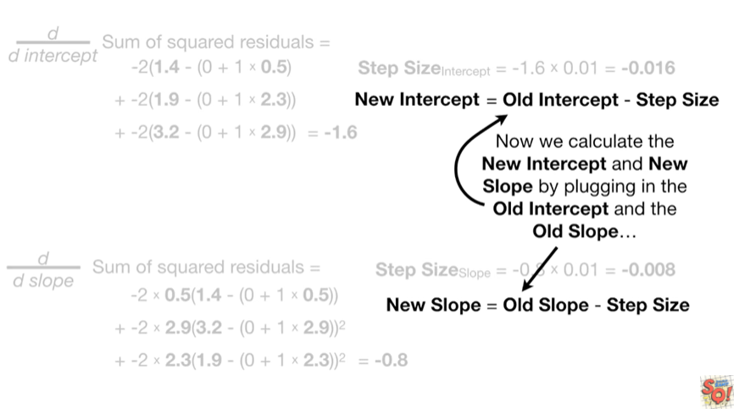

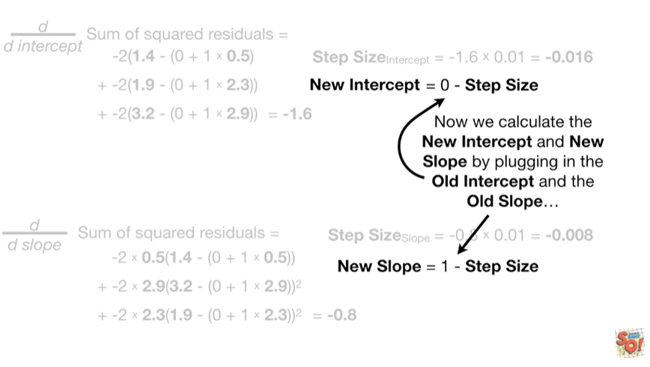

Now we calculate the new intercept and new slope by plugging in the old intercept and the old slope

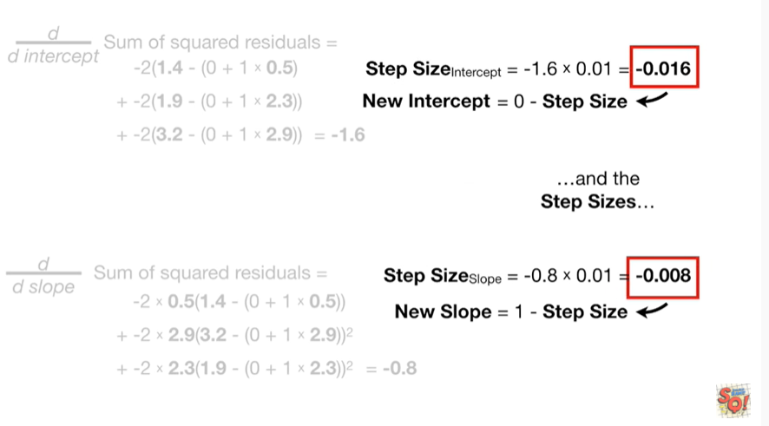

and the step sizes

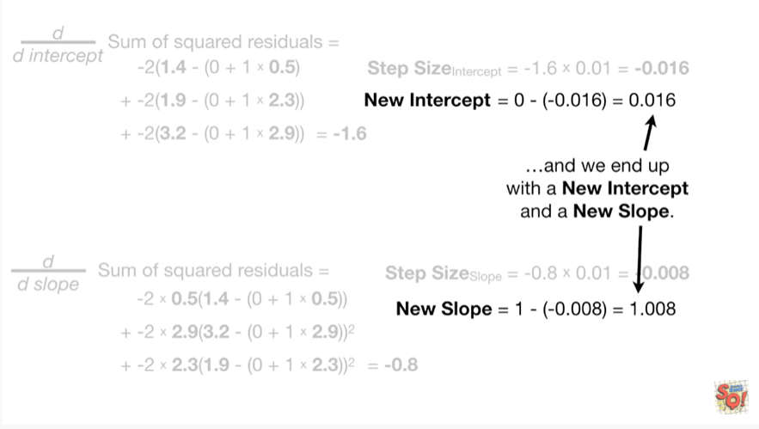

and we end up with a new intercept and a new slope.

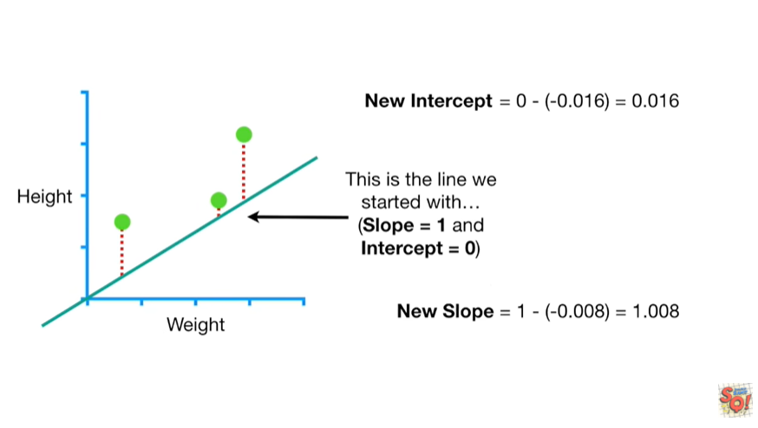

This is the line we started with

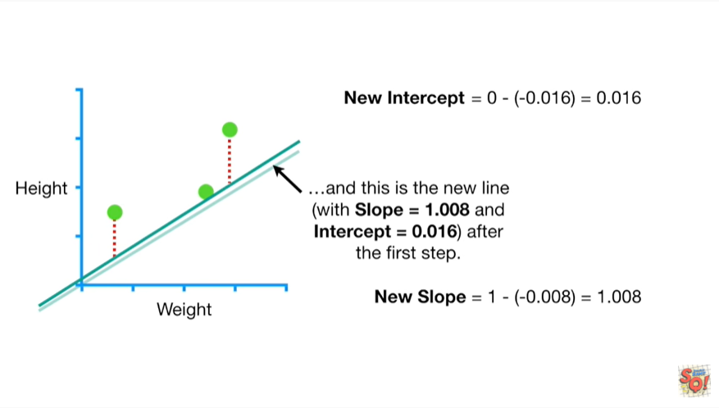

and this is the new line after the first step.

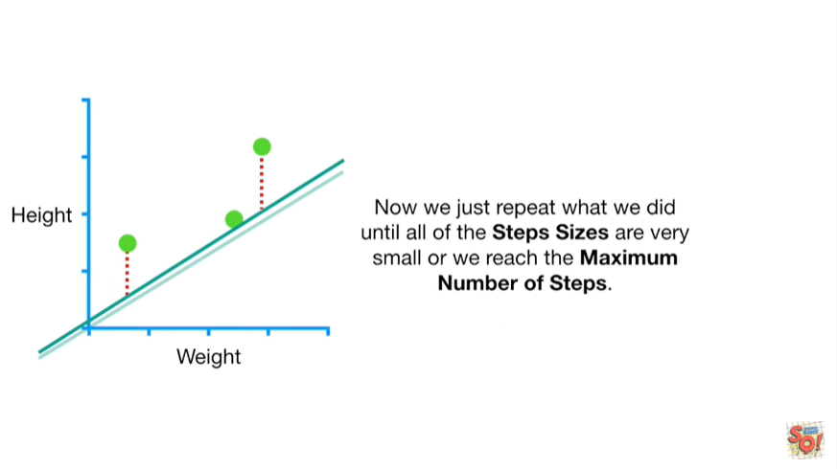

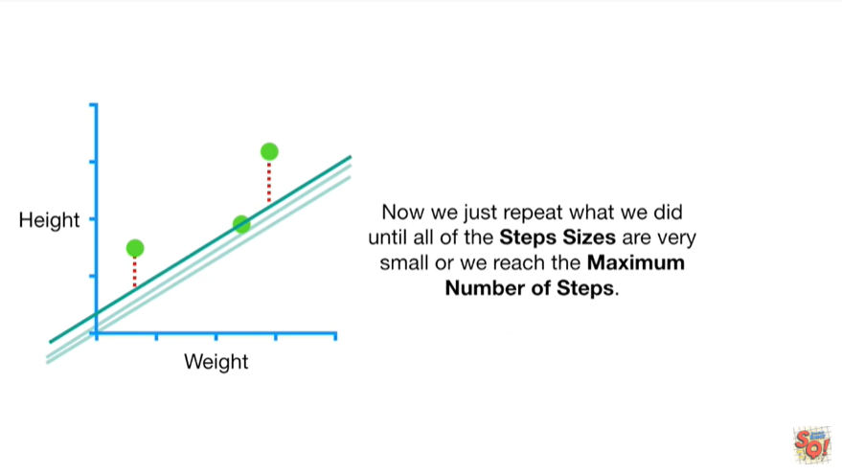

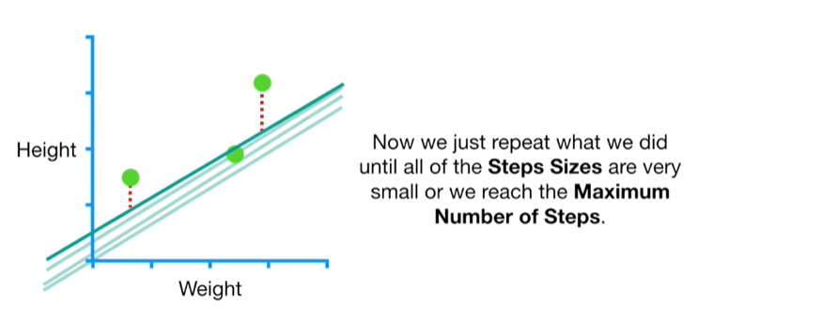

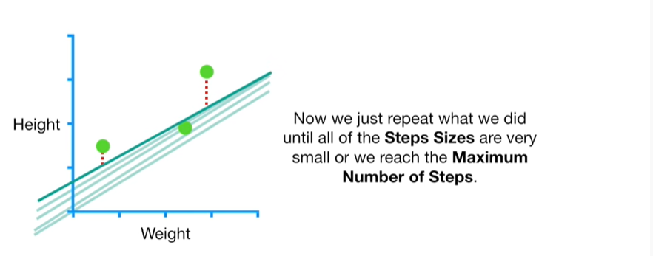

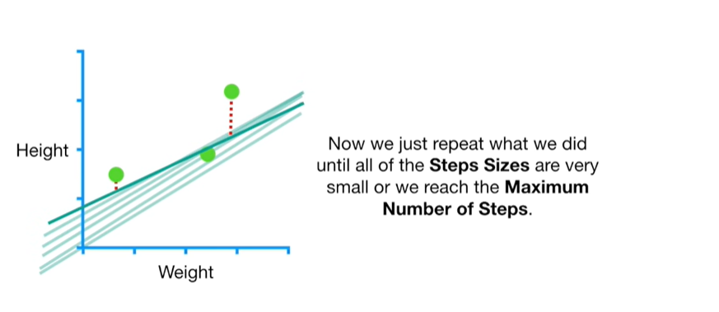

Now we just repeat what we did until all of the step sizes are very small or he reached the maximum number of steps.

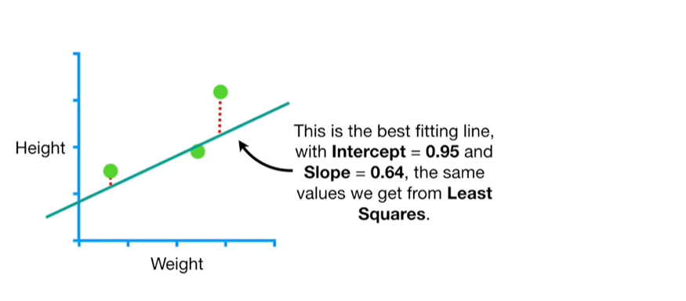

This is the best fitting line with intercept equals zero point nine five and slope equals zero point six for, the same values we get from least squares.

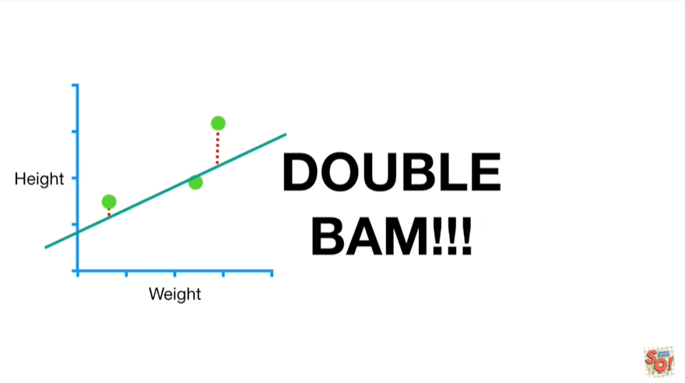

Double bam !!!

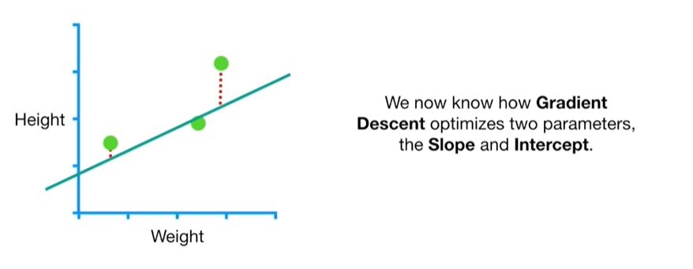

We now know how gradient descent optimizes two parameters, the slope and the intercept.

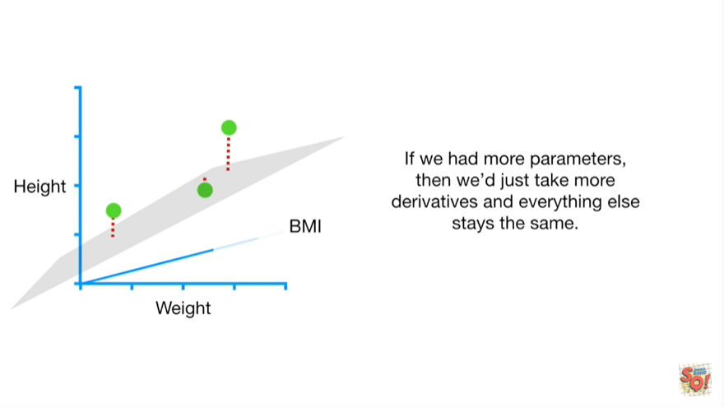

If we had more parameters, then we just take more derivatives and everything else stays the same.

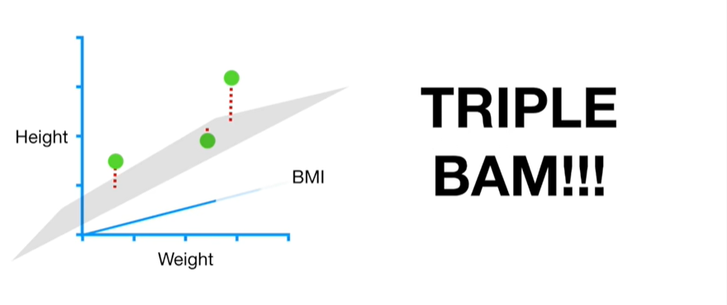

Triple bam !!!

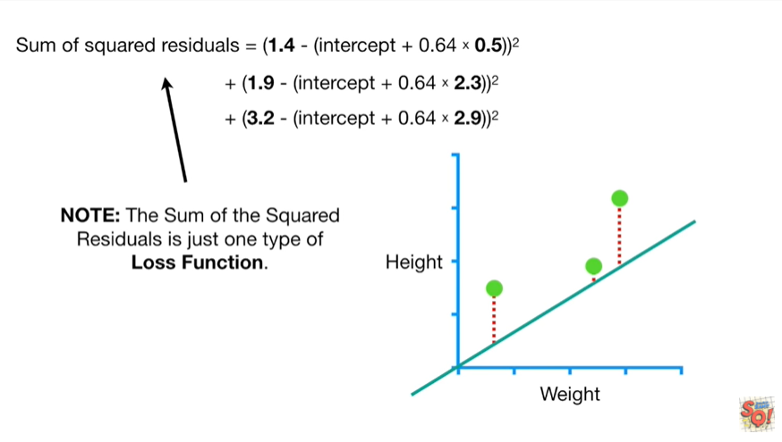

Note : the sum of the squared residuals is just one type of loss function.

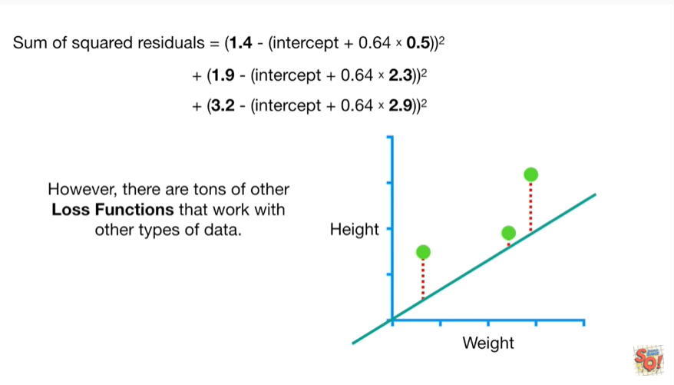

However there are tons of other loss functions that work with other types of data.

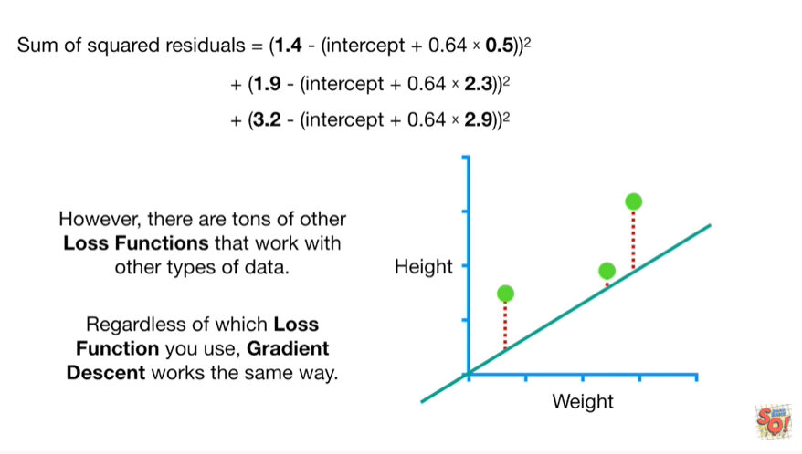

Regardless of which loss function you use, gradient descent works the same way.

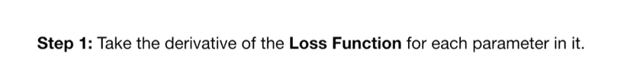

Step 1 : take the derivative of the loss function for each parameter in it.

In fancy machine learning lingo take the gradient of the loss function.

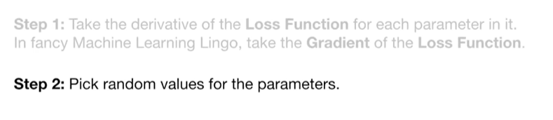

Step 2 : pick random values for the parameters.

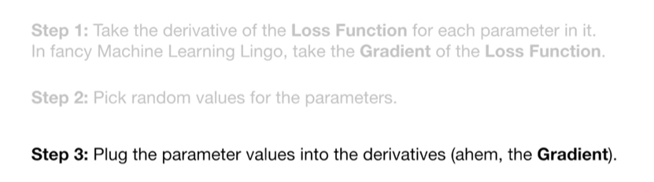

Step 3 : plug the parameter values into the derivatives (ahem the gradient).

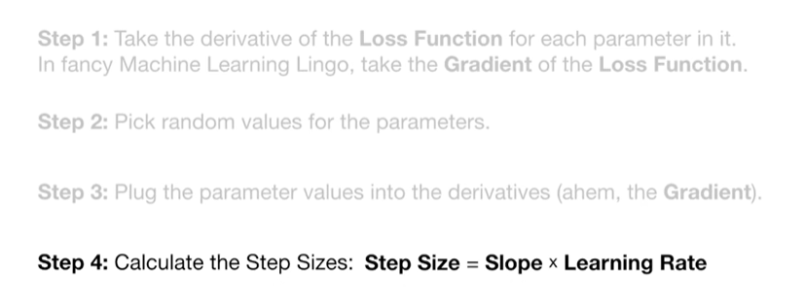

Step 4 : calculate the step sizes.

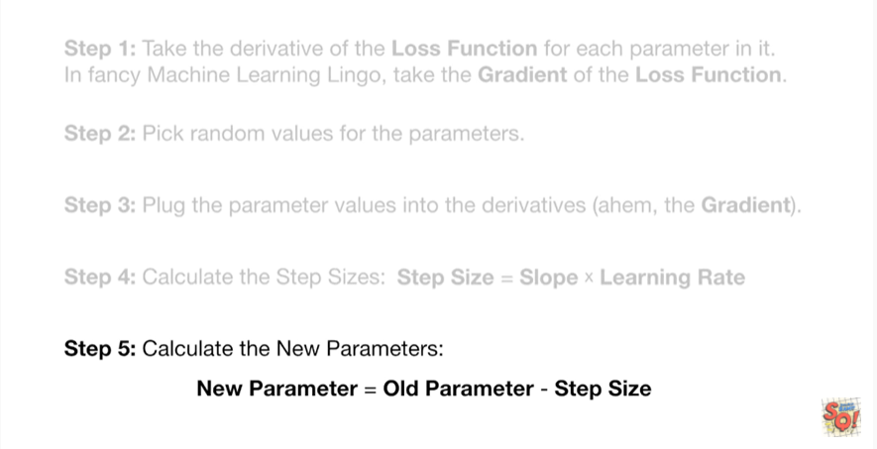

Step 5 : calculate the new parameters.

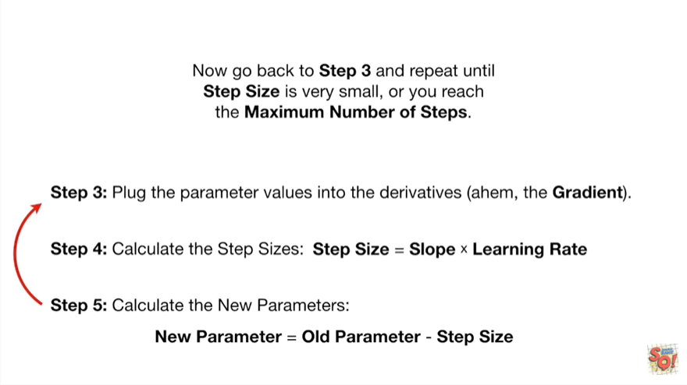

Now go back to step 3 and repeat until step size is very small or you reach the maximum number of steps.

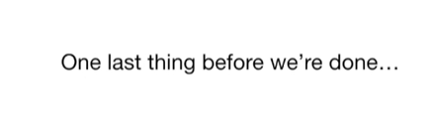

One last thing before we're done.

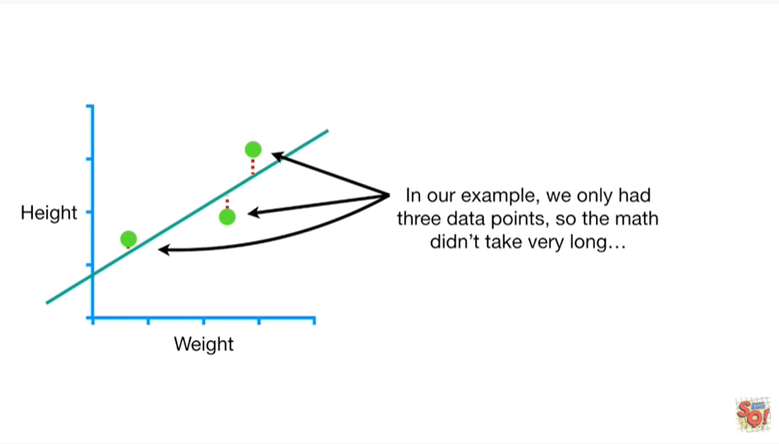

In our example, we only had three data points, so the math didn't take very long

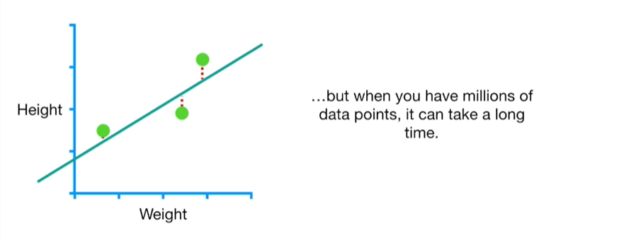

but when you have millions of data points, it can take a long time.

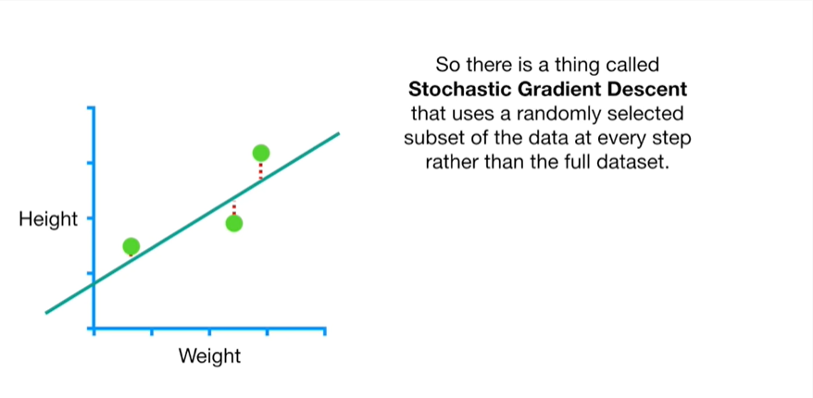

So there is a thing called stochastic gradient descent that uses a randomly selected subset of the data at every step rather than the full data set.

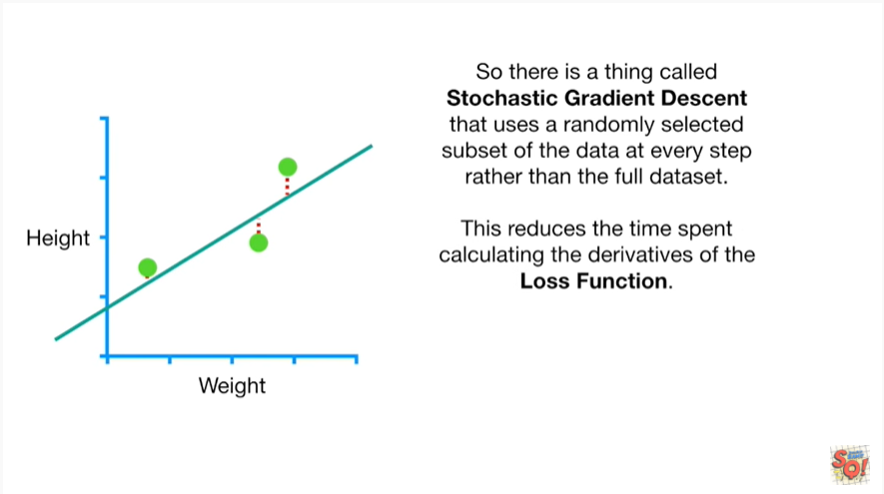

This reduces the time spent calculating the derivatives of the loss function.

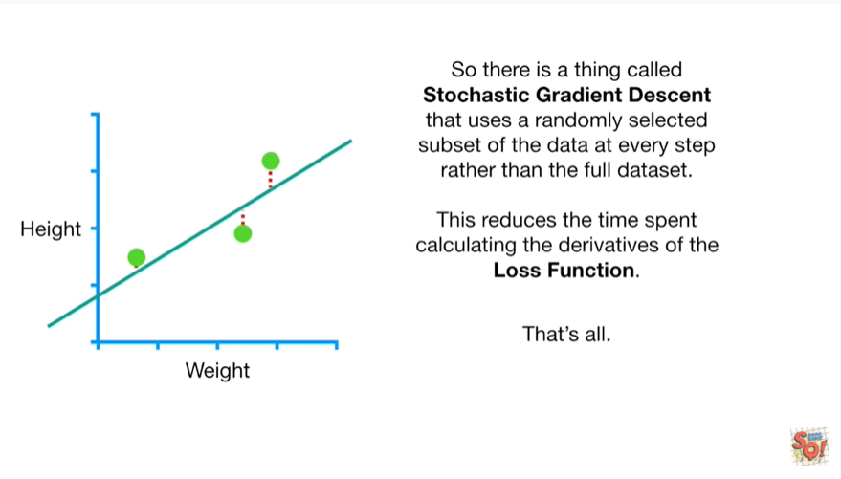

That's all.

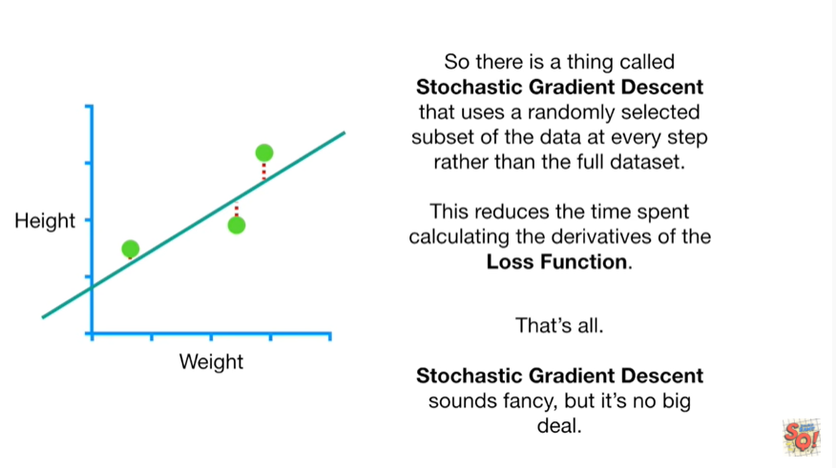

Stochastic gradient descent sounds fancy, but it's no big deal.